Prometheus and Grafana

- Install Prometheus on a server and configure prometheus.yml.
- Install and configure Node Exporter for system monitoring.
- Set up SNMP Exporter to monitor network devices.
- Set up Prometheus to run as a systemd service for automatic startup.
- Install Alertmanager and configure an email alert.
- Install Grafana and add Prometheus as a data source.
- Configure Prometheus for service discovery of dynamic targets.
- Create alerting rules for monitoring disk space.
- Create a custom Grafana dashboard using Prometheus metrics for specific insights.

Task 1 — Install Prometheus on AWS EC2 (Amazon Linux 2023)
No pictures. We'll use terminal commands, expected outputs, and verification checks only. We'll complete Task 1 only and stop before Node Exporter.

1.1 Objective
Install Prometheus on a new Amazon Linux 2023 EC2 instance, configure prometheus.yml, start Prometheus, and verify that its web interface and monitoring targets work.
Expected result: Prometheus is running on port 9090 and can collect its own metrics.

1.2 Architecture
Your EC2 instance will run Prometheus as a Linux process for this first task. In Task 4, we'll configure it as a systemd service for automatic startup.
Component | Configuration
Operating system | Amazon Linux 2023
Instance type | t3.small (2 vCPU, 2 GiB RAM)
Prometheus port | TCP 9090
Installation directory | /opt/prometheus
Configuration | /opt/prometheus/prometheus.yml
Metrics collection | Prometheus itself
A t3.micro may work for a basic test, but t3.small provides more room for the complete monitoring lab. Check current pricing and your available credits before launching.

1.3 Create the EC2 instance
- Open the AWS EC2 Console.
- Select Launch instance.
- Enter these settings:
  - Name: prometheus-server
  - AMI: Amazon Linux 2023 AMI
  - Instance type: t3.small
  - Key pair: Create or select a key pair you can access.
  - Storage: 8 GiB gp3 is sufficient for this initial lab, subject to available AMI defaults.
  - Public IP: Enable a public IPv4 address if you want to connect directly over SSH.
- Under Network settings, create or select a security group as described below.
- Launch the instance and wait until its instance state is Running and status checks pass.

1.4 Configure the security group
In the EC2 console, open your instance's Security tab, select the security group, and edit inbound rules.
Type | Port | Source
SSH | 22 | My IP
Custom TCP | 9090 | My IP (only if accessing the UI directly)
Do not expose Prometheus port 9090 to 0.0.0.0/0. If you don't need direct browser access, skip the inbound rule for 9090 and use an SSH tunnel later.

1.5 Connect to the EC2 instance
From your computer, connect using SSH. Replace the key path and public IP with your actual values.
ssh -i "your-key.pem" ec2-user@YOUR_EC2_PUBLIC_IP
On Windows, use the terminal where your downloaded .pem key is accessible. If you use EC2 Instance Connect instead, open a terminal from the instance's Connect page.
Verify the operating system:
cat /etc/os-release
Expected output should identify Amazon Linux 2023:
NAME="Amazon Linux"
VERSION="2023"
Check the machine architecture:
uname -m
Expected:
x86_64

1.6 Install prerequisites
Run these commands on the EC2 instance:
sudo dnf update -y
sudo dnf install -y curl tar gzip
Verify:
curl --version
tar --version
Both commands should display their installed versions.
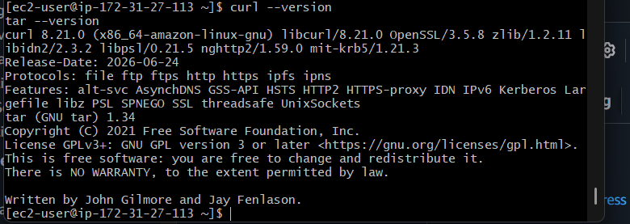

1.7 Download and install Prometheus
We'll install the latest published Prometheus release automatically, rather than hard-coding an older version.
First, create a dedicated Linux user and directories:
sudo useradd --system --no-create-home --shell /sbin/nologin prometheus

sudo mkdir -p /etc/prometheus
sudo mkdir -p /var/lib/prometheus
sudo mkdir -p /opt/Prometheus
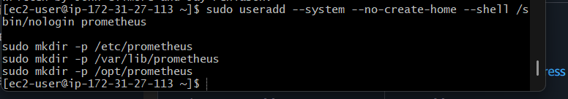
Download the latest release and extract it:
cd /tmp

VERSION=$(curl -fsSL https://api.github.com/repos/prometheus/prometheus/releases/latest \
| grep '"tag_name":' | head -1 | cut -d '"' -f4 | sed 's/^v//')

echo "Prometheus version: $VERSION"
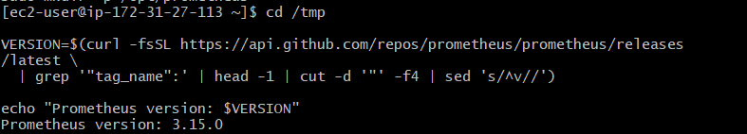
Verify that a version number was returned before continuing. Then run:
curl -fL -o prometheus.tar.gz \
"https://github.com/prometheus/prometheus/releases/download/v${VERSION}/prometheus-${VERSION}.linux-amd64.tar.gz"

tar -xzf prometheus.tar.gz

sudo cp "prometheus-${VERSION}.linux-amd64/prometheus" /usr/local/bin/
sudo cp "prometheus-${VERSION}.linux-amd64/promtool" /usr/local/bin/
sudo cp "prometheus-${VERSION}.linux-amd64/consoles" /opt/prometheus/
sudo cp "prometheus-${VERSION}.linux-amd64/console_libraries" /opt/prometheus/
Verify the binaries:
prometheus --version
promtool –version
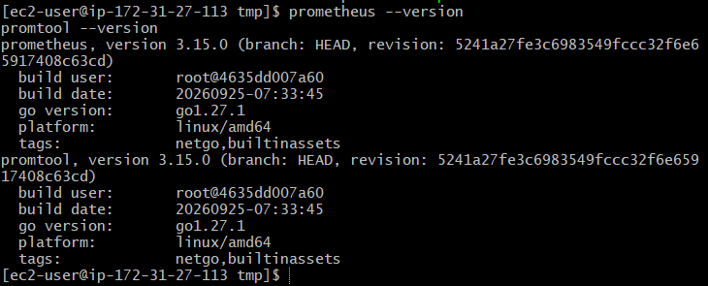
You should see the Prometheus version and build information. Both commands should execute without errors.

1.8 Configure prometheus.yml
Create the configuration file:
sudo tee /etc/prometheus/prometheus.yml > /dev/null <<'EOF'
global:
scrape_interval: 15s
evaluation_interval: 15s

scrape_configs:
- job_name: "prometheus"
static_configs:
- targets: ["localhost:9090"]
EOF
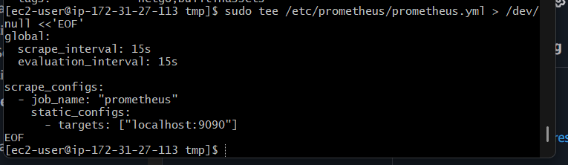
Understand the configuration:
Setting | Meaning
scrape_interval: 15s | Collect metrics every 15 seconds
evaluation_interval: 15s | Evaluate alerting and recording rules every 15 seconds
job_name: prometheus | Identifies this monitoring target
localhost:9090 | Prometheus collects metrics from itself
Check the file:
sudo cat /etc/prometheus/prometheus.yml
Validate the syntax:
sudo promtool check config /etc/prometheus/prometheus.yml
Expected output:
SUCCESS: /etc/prometheus/prometheus.yml is valid prometheus config file syntax
The exact wording can vary by release, but validation must succeed.
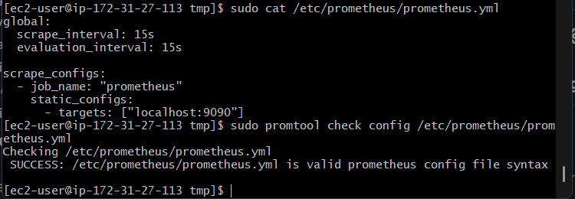

1.9 Set permissions
Prometheus needs permission to read its configuration and write its metrics database.
sudo chown -R prometheus:prometheus /etc/prometheus
sudo chown -R prometheus:prometheus /var/lib/prometheus
sudo chown -R prometheus:prometheus /opt/prometheus
Verify:
ls -ld /etc/prometheus /var/lib/prometheus /opt/prometheus
The directories should be owned by prometheus.
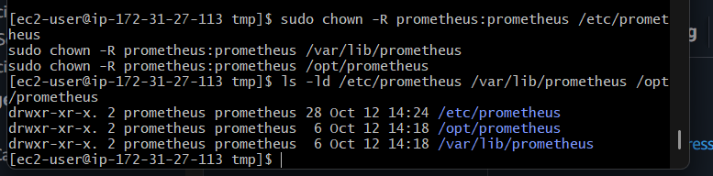

1.10 Start Prometheus for the first test
For Task 1, start it manually. We'll create a proper systemd service in Task 4.
sudo -u prometheus /usr/local/bin/prometheus \
--config.file=/etc/prometheus/prometheus.yml \
--storage.tsdb.path=/var/lib/prometheus \
--web.listen-address=0.0.0.0:9090 \
> /tmp/prometheus.log 2>&1 &
Wait a few seconds, then check the process:
pgrep -a Prometheus
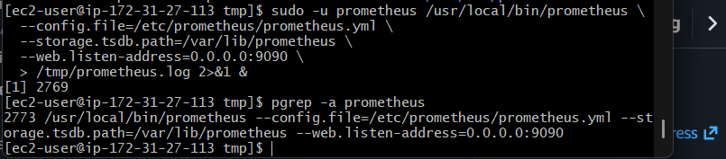
You should see a running Prometheus process with the configuration and storage paths in its command line.
Check its logs:
sudo tail -n 30 /tmp/prometheus.log
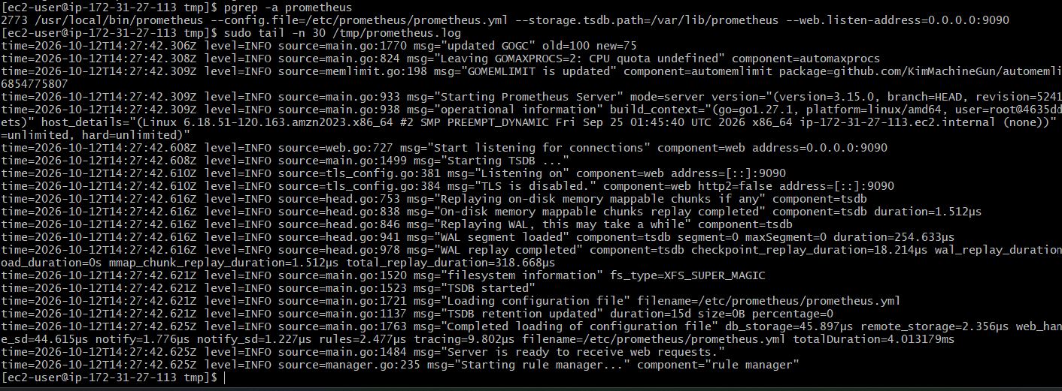
Look for messages indicating that the web listener has started and the server is ready. If the process exits, inspect this log before proceeding.
Test locally on EC2:
curl -s http://localhost:9090/-/ready
Expected:
Prometheus Server is Ready.
Also check its health:
curl -s http://localhost:9090/-/healthy
Expected:
Prometheus Server is Healthy.
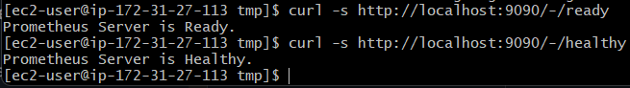

1.11 Access the Prometheus web interface
Open this URL in your computer's browser, replacing the placeholder with the EC2 public IPv4 address:
http://YOUR_EC2_PUBLIC_IP:9090
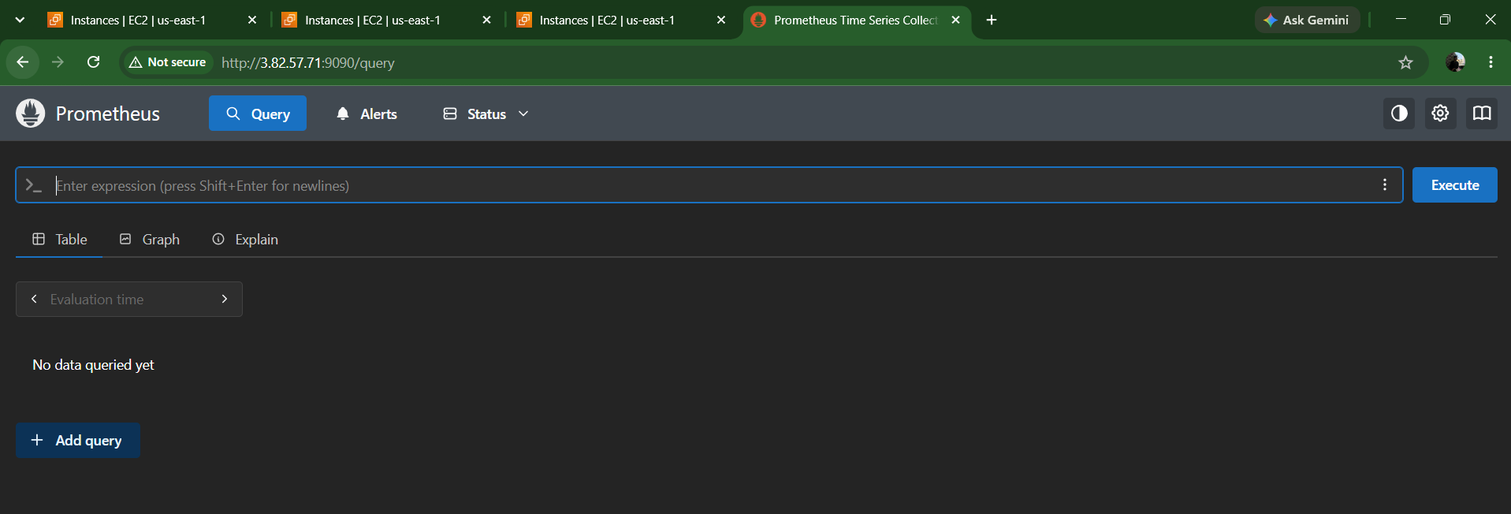
If the page doesn't load, verify that the security group allows TCP 9090 from your current public IP, that Prometheus is running, and that you're using the correct public address.
In the Prometheus interface:
- Open Status → Targets.
- Find the prometheus job.
- Confirm that its state is UP.
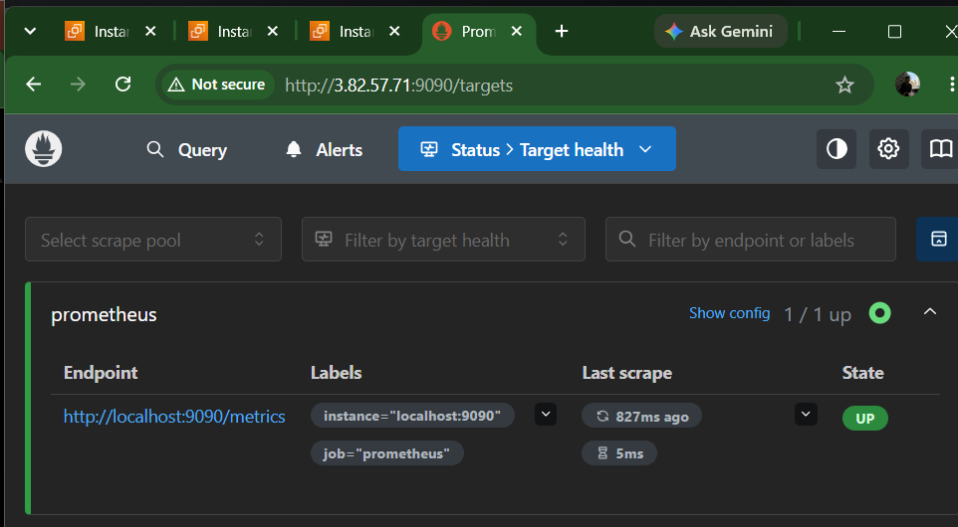
- Open Graph and run this query:
Up
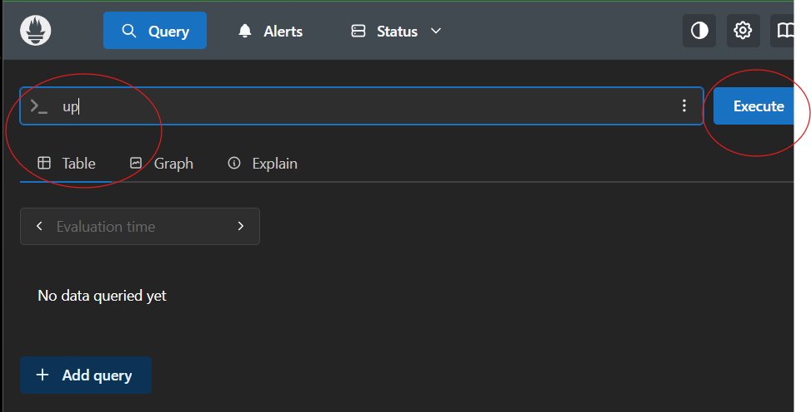
Expected result:
up{instance="localhost:9090", job="prometheus"} 1
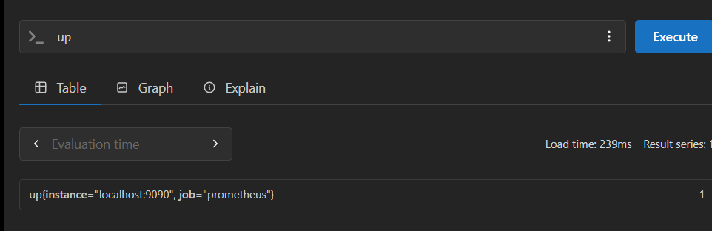
A value of 1 means Prometheus successfully scraped its own metrics.
You can also query:
prometheus_build_info
This should return build-information metrics for the running Prometheus server.
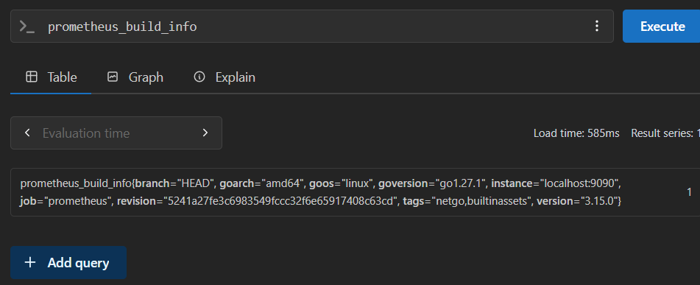

Task 2 — Install and Configure Node Exporter

2.1 Objective
Install Node Exporter on your existing Amazon Linux 2023 EC2 instance to collect system-level metrics such as CPU, memory, disk usage, and network traffic. Then configure Prometheus to scrape those metrics.

2.2 Expected architecture
Node Exporter
Port 9100 — collects Linux system metrics
Prometheus
Port 9090 — scrapes and stores metrics
PromQL queries
CPU, RAM, disk and network insights

2.3 Download Node Exporter
Run these commands on your existing EC2 instance (ec2-user). Do not create another instance.
Create a dedicated user:
sudo useradd --system --no-create-home --shell /sbin/nologin node_exporter
If the user already exists, continue without recreating it.
Get the latest release version:
cd /tmp

VERSION=$(curl -fsSL https://api.github.com/repos/prometheus/node_exporter/releases/latest \
| grep '"tag_name":' | head -1 | cut -d '"' -f4 | sed 's/^v//')

echo "Node Exporter version: $VERSION"
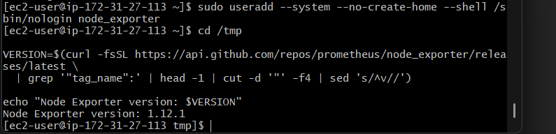
Download and extract it:
curl -fL -o node_exporter.tar.gz \
"https://github.com/prometheus/node_exporter/releases/download/v${VERSION}/node_exporter-${VERSION}.linux-amd64.tar.gz"

tar -xzf node_exporter.tar.gz
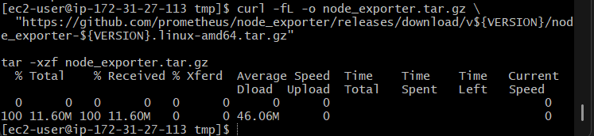
Install the binary:
sudo cp "/tmp/node_exporter-${VERSION}.linux-amd64/node_exporter" /usr/local/bin/
sudo chown node_exporter:node_exporter /usr/local/bin/node_exporter
Verify:
node_exporter –version
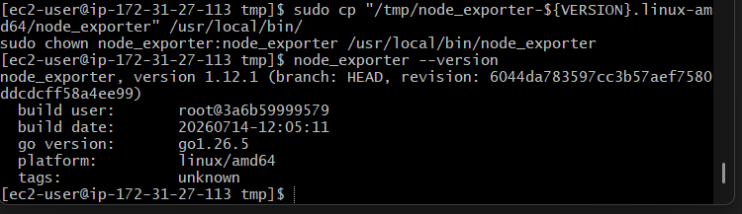
You should see the installed Node Exporter version.

2.4 Start Node Exporter
For this task, run it manually first. We'll verify the metrics before configuring Prometheus.
sudo -u node_exporter /usr/local/bin/node_exporter \
> /tmp/node_exporter.log 2>&1 &
Verify that the process is running:
pgrep -a node_exporter
Check its metrics endpoint:
curl -s http://localhost:9100/metrics | head
You should see metric lines beginning with # HELP, # TYPE, or metric names.
Check specific metrics:
curl -s http://localhost:9100/metrics | grep '^node_cpu_seconds_total' | head
This metric records CPU time spent in different modes.
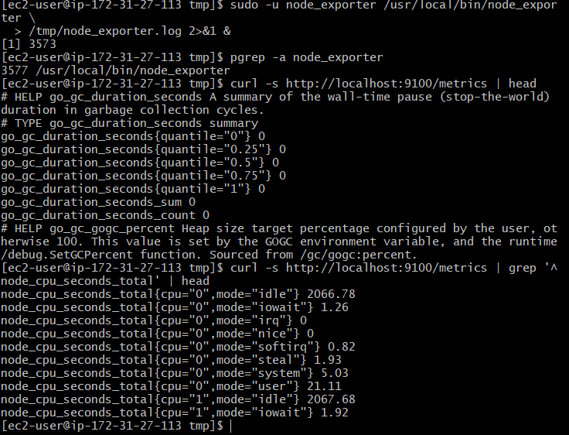

2.5 Configure Prometheus to scrape Node Exporter
Back up your current configuration:
sudo cp /etc/prometheus/prometheus.yml \
/etc/prometheus/prometheus.yml.task1-backup
Open the file:
sudo vi /etc/prometheus/prometheus.yml
Keep the existing Prometheus job and add the node_exporter job so the file looks like this:
global:
scrape_interval: 15s
evaluation_interval: 15s

scrape_configs:
- job_name: "prometheus"
static_configs:
- targets: ["localhost:9090"]

- job_name: "node_exporter"
static_configs:
- targets: ["localhost:9100"]
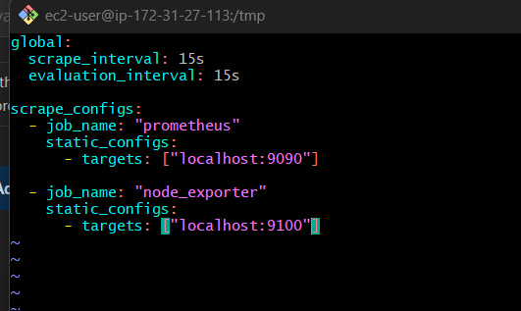
In vi, press i to edit, then press Esc, type :wq, and press Enter to save.
Validate the configuration:
sudo promtool check config /etc/prometheus/prometheus.yml
Proceed only if validation succeeds.
Reload the configuration by restarting the currently running Prometheus process. Because Prometheus was started manually in Task 1, first identify its PID:
pgrep -a prometheus
Then stop the existing Prometheus process gracefully and start it again with the same command used in Task 1:
sudo pkill -TERM -x prometheus
Wait a moment, then start it again:
sudo -u prometheus /usr/local/bin/prometheus \
--config.file=/etc/prometheus/prometheus.yml \
--storage.tsdb.path=/var/lib/prometheus \
--web.listen-address=0.0.0.0:9090 \
> /tmp/prometheus.log 2>&1 &
If the process does not stop or restart as expected, check pgrep -a prometheus and the log before trying again.
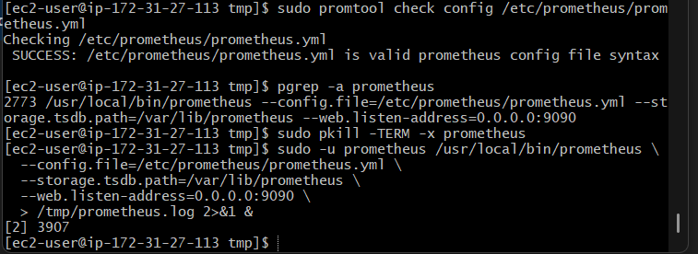

2.6 Verify Node Exporter in Prometheus
Open your Prometheus page:
http://YOUR_EC2_PUBLIC_IP:9090/targets
You should now see two targets:
Job | Endpoint | Expected state
prometheus | localhost:9090 | UP
node_exporter | localhost:9100 | UP
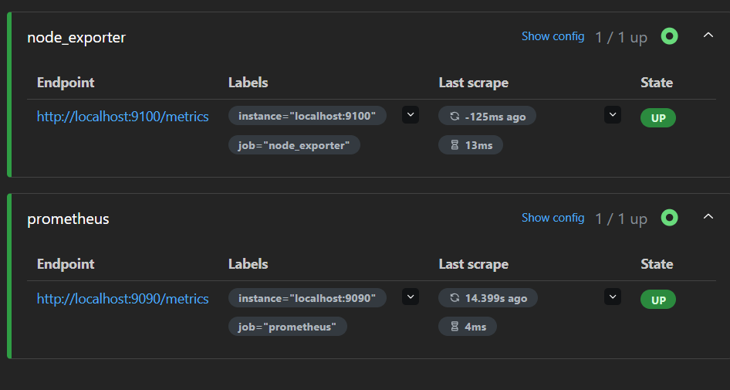
Wait at least 15 seconds for the first scrape.
Open Query and run:
up{job="node_exporter"}
Expected value:
1
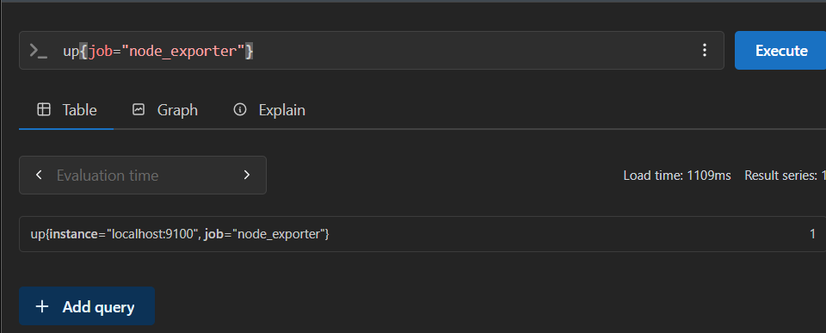
Now test CPU metrics:
node_cpu_seconds_total
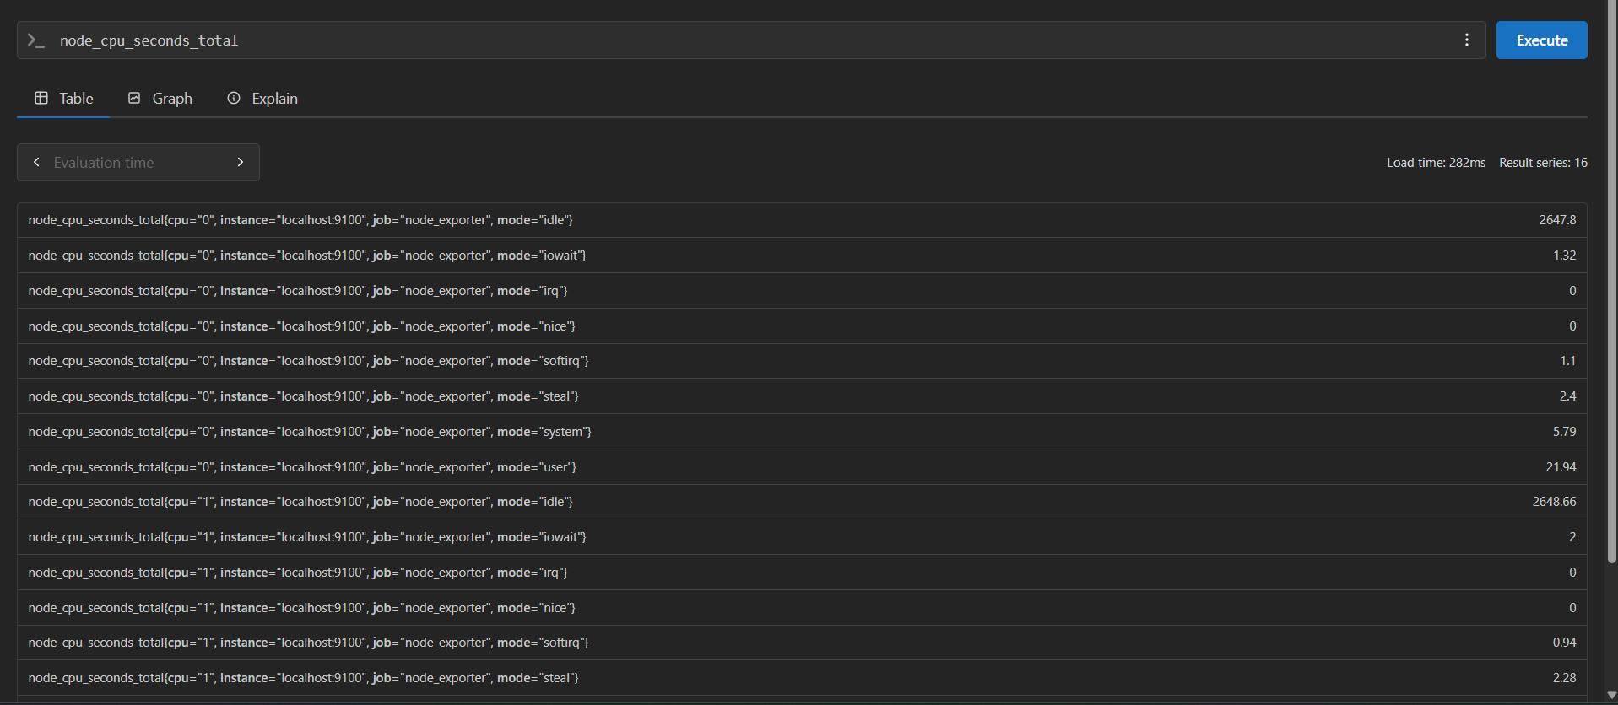
Then memory metrics:
node_memory_MemAvailable_bytes
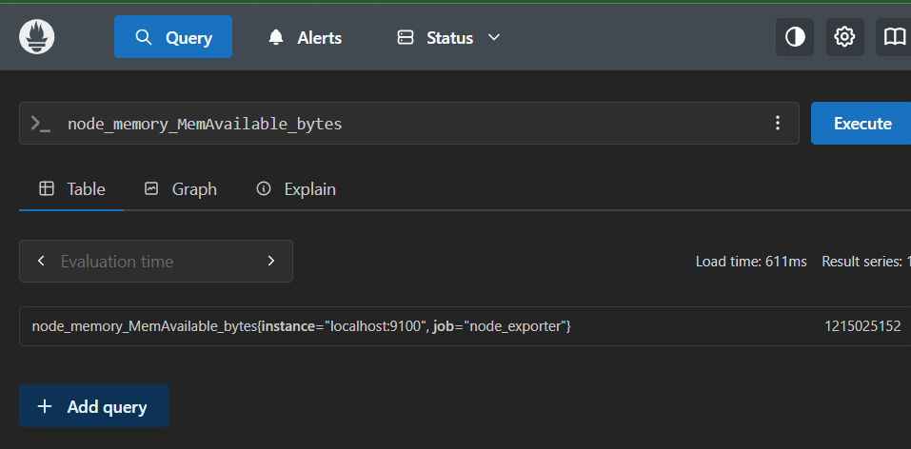
And disk-size metrics:
node_filesystem_size_bytes
These queries should return metric series for your Linux host.
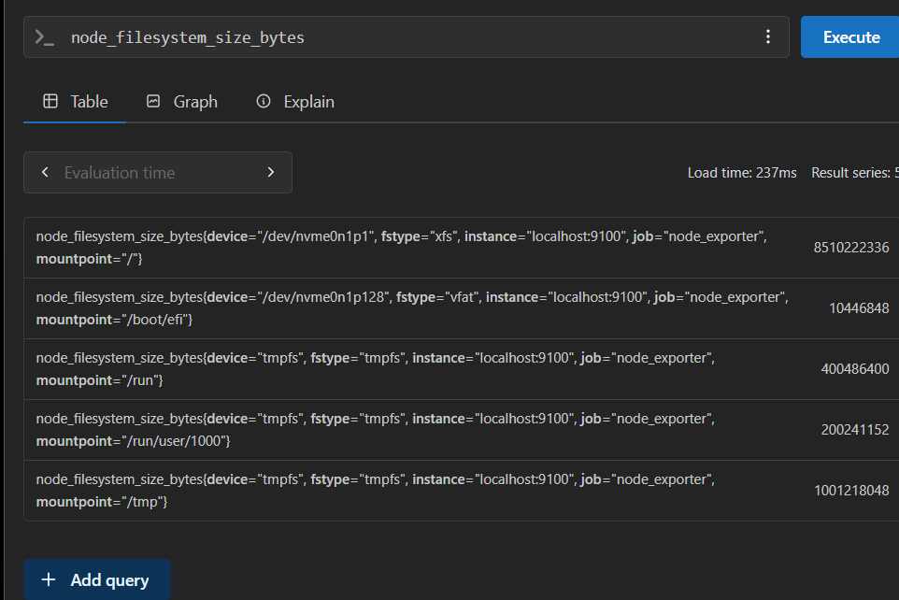

Task 3 — Install and Configure SNMP Exporter

3.1 Objective
Install SNMP Exporter on your existing Amazon Linux 2023 EC2 instance and configure Prometheus to collect network-device metrics using SNMP.

3.2 Architecture
SNMP-enabled network device
Router / switch / device — UDP 161
SNMP Exporter
TCP 9116 — exposes metrics to Prometheus
Prometheus
TCP 9090 — scrapes SNMP Exporter

3.3 Implementation steps

Step 1 — Download SNMP Exporter
On your existing EC2 instance:
cd /tmp

VERSION=$(curl -fsSL https://api.github.com/repos/prometheus/snmp_exporter/releases/latest \
| grep '"tag_name":' | head -1 | cut -d '"' -f4 | sed 's/^v//')

echo "$VERSION"
Download and extract:
curl -fL -o snmp_exporter.tar.gz \
"https://github.com/prometheus/snmp_exporter/releases/download/v${VERSION}/snmp_exporter-${VERSION}.linux-amd64.tar.gz"

tar -xzf snmp_exporter.tar.gz
Install the binary:
sudo cp "/tmp/snmp_exporter-${VERSION}.linux-amd64/snmp_exporter" /usr/local/bin/
Verify:
snmp_exporter –version
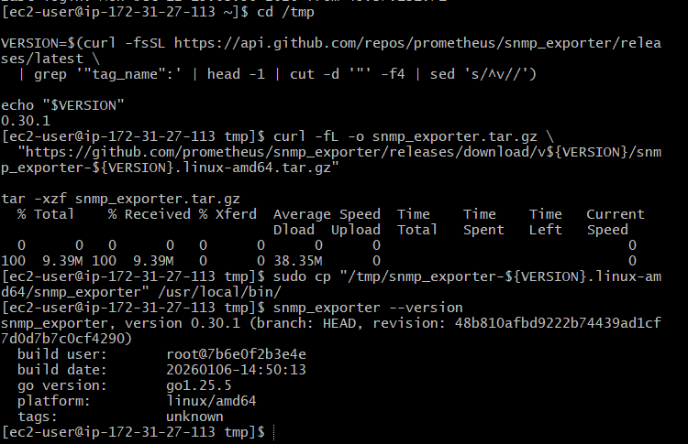

Step 2 — Start SNMP Exporter
sudo useradd --system --no-create-home --shell /sbin/nologin snmp_exporter
If the user already exists, continue.
sudo -u snmp_exporter /usr/local/bin/snmp_exporter \
> /tmp/snmp_exporter.log 2>&1 &
Verify:
curl -s http://localhost:9116/metrics | head
You should see exporter process metrics.
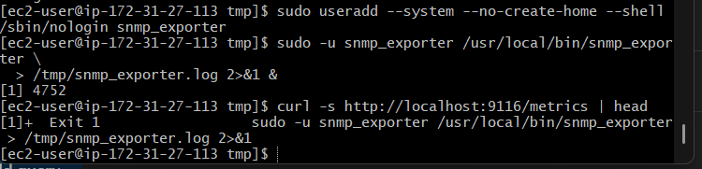

Step 3 — Configure Prometheus
Back up the configuration:
sudo cp /etc/prometheus/prometheus.yml \
/etc/prometheus/prometheus.yml.task3-backup
Edit it:
sudo vi /etc/prometheus/prometheus.yml
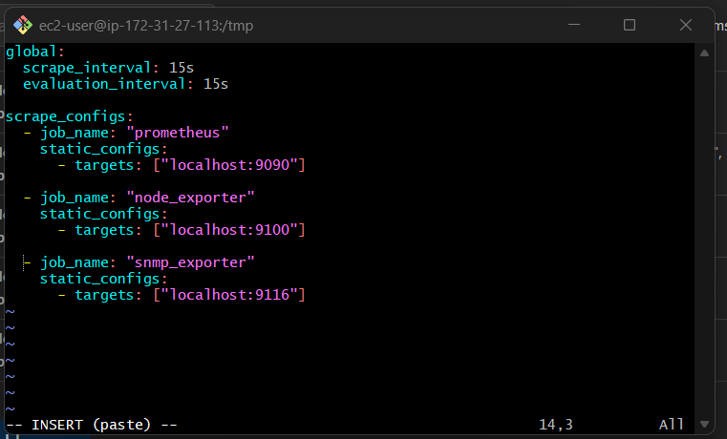
Add this scrape job under scrape_configs, keeping your existing Prometheus and Node Exporter jobs:
- job_name: "snmp_exporter"
static_configs:
- targets: ["localhost:9116"]
Validate:
sudo promtool check config /etc/prometheus/prometheus.yml
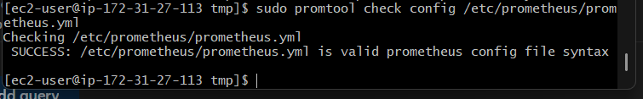
Restart your manually running Prometheus process using the procedure from Task 2, then check:
http://YOUR_EC2_PUBLIC_IP:9090/targets
The snmp_exporter target should show UP
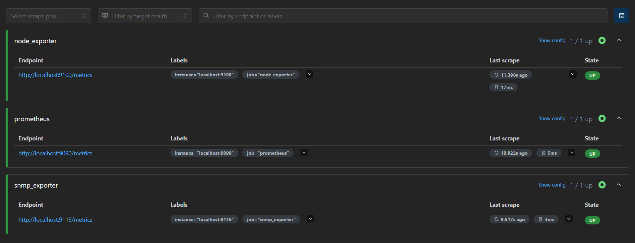.
Important: This verifies the exporter endpoint only. Actual network-device metrics require a reachable SNMP-enabled device, an appropriate SNMP configuration, and a target-specific scrape configuration. Do not treat exporter health as proof that a router or switch is being monitored.

3.4 Outcome
- SNMP Exporter is installed and exposes its own metrics.
- Prometheus can scrape the exporter on port 9116.
- Network-device monitoring can be added once an SNMP target and its configuration are available.

Task 4 — Configure Prometheus as a systemd Service

4.1 Objective
Configure Prometheus to run as a systemd service on your existing AWS EC2 instance running Amazon Linux 2023. This ensures Prometheus starts automatically after a reboot and can be managed using systemctl.

4.2 Architecture
EC2 boots → systemd starts Prometheus → Prometheus loads prometheus.yml → scrapes configured targets.

4.3 Implementation steps

Step 1 — Check the existing Prometheus process
Run on your EC2 instance:
pgrep -a prometheus
Because Prometheus is currently running manually, stop the existing process before starting it as a service:
sudo pkill -TERM -x prometheus
Verify it has stopped:
pgrep -a Prometheus
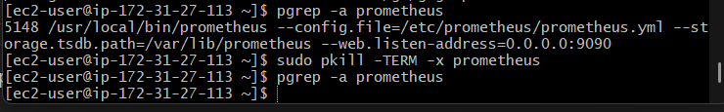
No output means no matching process remains. If one remains, investigate before continuing.

Step 2 — Create the systemd service file
sudo vi /etc/systemd/system/prometheus.service
Press i and add:
[Unit]
Description=Prometheus Monitoring System
Wants=network-online.target
After=network-online.target

[Service]
User=prometheus
Group=prometheus
Type=simple
ExecStart=/usr/local/bin/prometheus \
--config.file=/etc/prometheus/prometheus.yml \
--storage.tsdb.path=/var/lib/prometheus \
--web.listen-address=0.0.0.0:9090
Restart=on-failure
RestartSec=5s

[Install]
WantedBy=multi-user.target
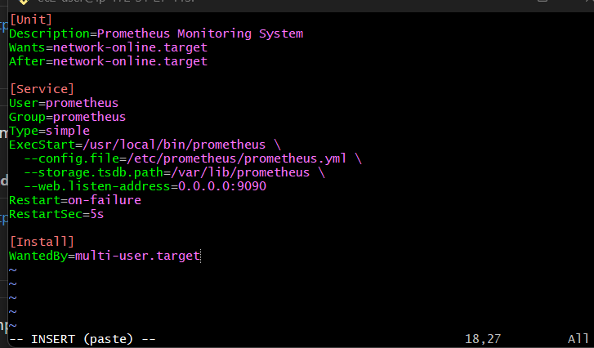
Save the file by pressing Esc, typing :wq, and pressing Enter.
Security note: This preserves your current listener configuration. Keep port 9090 restricted to your own IP in the EC2 security group.

Step 3 — Reload systemd and enable Prometheus
sudo systemctl daemon-reload
sudo systemctl enable --now Prometheus
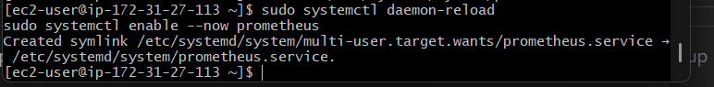
Expected output may indicate that a symlink was created for the service. The enable command configures automatic startup at boot, while --now starts the service immediately.

Step 4 — Verify service status
sudo systemctl status prometheus --no-pager
Look for:
Active: active (running)
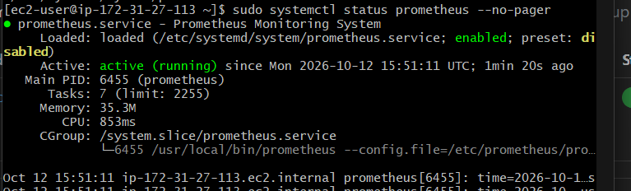
Also verify automatic startup:
sudo systemctl is-enabled prometheus
Expected:
enabled

Step 5 — Verify Prometheus readiness
curl -s http://localhost:9090/-/ready
Expected:
Prometheus Server is Ready.
Check the targets:
curl -s http://localhost:9090/api/v1/targets
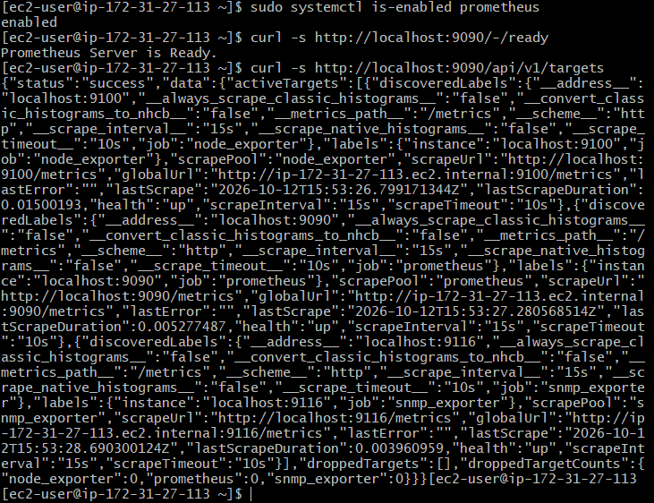
Or open http://YOUR_EC2_PUBLIC_IP:9090/targets in your browser. Your Prometheus target and the exporters you configured should remain UP.
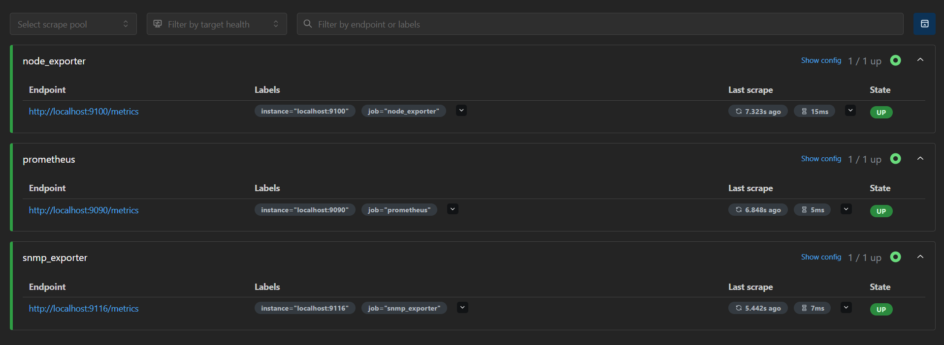

Step 6 — Test service restart
sudo systemctl restart prometheus
sudo systemctl is-active prometheus
Expected:
Active
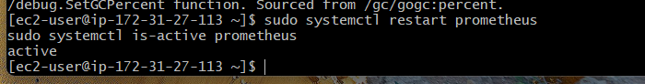
Check the logs if anything fails:
sudo journalctl -u prometheus -n 50 --no-pager

4.4 Outcome
- Prometheus runs under systemd.
- Prometheus starts automatically when the instance boots.
- You can manage it using systemctl start, stop, restart, and status.
- Its configuration and metrics storage remain in /etc/prometheus/prometheus.yml and /var/lib/prometheus.

Task 5 — Install and Configure Alertmanager with Email Alerts

5.1 Objective
Install Alertmanager on your existing Amazon Linux 2023 EC2 instance and configure email notifications for Prometheus alerts.
By the end of this task, Prometheus will send firing alerts to Alertmanager, and Alertmanager will route them to your email address.

5.2 Architecture
Prometheus
Evaluates alerting rules
Alertmanager — TCP 9093
Groups, routes and manages alerts
SMTP email server
Delivers notifications to your inbox

5.3 Implementation

Step 1 — Choose your email configuration
For this lab, Gmail SMTP is one option. You'll need:
- The email address that will send alerts.
- An email address that will receive alerts.
- A Gmail App Password if the sender account uses Gmail with 2-Step Verification enabled. Do not use your regular Gmail password.

Step 2 — Download Alertmanager
Run on your existing EC2 instance:
cd /tmp

VERSION=$(curl -fsSL https://api.github.com/repos/prometheus/alertmanager/releases/latest \
| grep '"tag_name":' | head -1 | cut -d '"' -f4 | sed 's/^v//')

echo "Alertmanager version: $VERSION"
Download and extract:
curl -fL -o alertmanager.tar.gz \
"https://github.com/prometheus/alertmanager/releases/download/v${VERSION}/alertmanager-${VERSION}.linux-amd64.tar.gz"

tar -xzf alertmanager.tar.gz
Create the service user and directories:
sudo useradd --system --no-create-home --shell /sbin/nologin alertmanager

sudo mkdir -p /etc/alertmanager /var/lib/alertmanager
Install the binaries:
sudo cp "/tmp/alertmanager-${VERSION}.linux-amd64/alertmanager" /usr/local/bin/
sudo cp "/tmp/alertmanager-${VERSION}.linux-amd64/amtool" /usr/local/bin/
Verify:
alertmanager --version
amtool –version
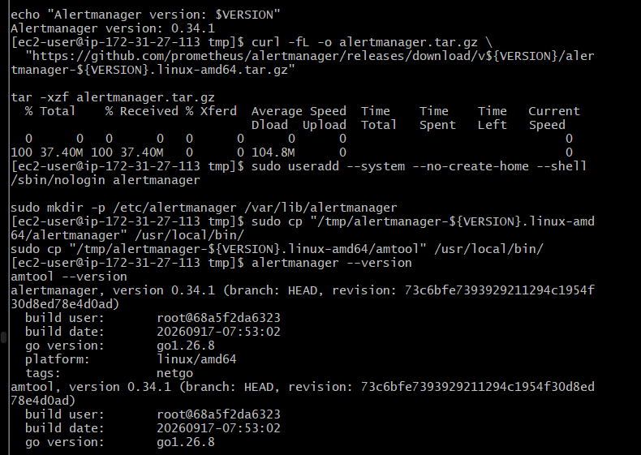
If the alertmanager user already exists, continue without recreating it.

Step 3 — Configure email notifications
For this example, we'll use Gmail SMTP.
If you're using Gmail, create an App Password from your Google Account's security settings after enabling 2-Step Verification. Keep the App Password secret.
Create the configuration:
sudo vi /etc/alertmanager/alertmanager.yml
Add the following, replacing the example email addresses and password:
global:
smtp_smarthost: 'smtp.gmail.com:587'
smtp_from: 'sender@gmail.com'
smtp_auth_username: 'sender@gmail.com'
smtp_auth_password: 'YOUR_16_CHARACTER_APP_PASSWORD'
smtp_require_tls: true

route:
receiver: 'email-alerts'
group_by: ['alertname']
group_wait: 10s
group_interval: 1m
repeat_interval: 1h

receivers:
- name: 'email-alerts'
email_configs:
- to: 'recipient@example.com'
send_resolved: true
Replace:
- sender@gmail.com with your sending Gmail account.
- YOUR_16_CHARACTER_APP_PASSWORD with the App Password.
- recipient@example.com with the inbox where you want to receive alerts.
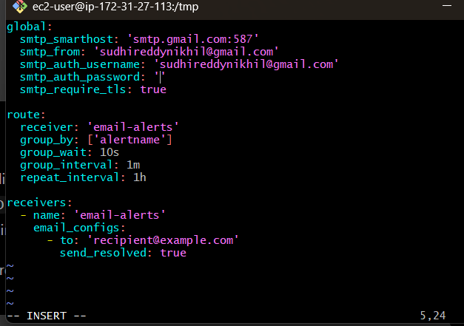
Save the file and restrict access to the credentials:
sudo chown -R alertmanager:alertmanager /etc/alertmanager /var/lib/alertmanager
sudo chmod 600 /etc/alertmanager/alertmanager.yml
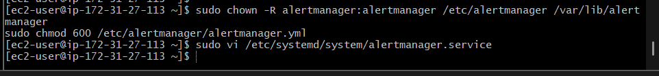

Step 4 — Create a systemd service
sudo vi /etc/systemd/system/alertmanager.service
Add:
[Unit]
Description=Prometheus Alertmanager
Wants=network-online.target
After=network-online.target

[Service]
User=alertmanager
Group=alertmanager
Type=simple
ExecStart=/usr/local/bin/alertmanager \
--config.file=/etc/alertmanager/alertmanager.yml \
--storage.path=/var/lib/alertmanager \
--web.listen-address=0.0.0.0:9093
Restart=on-failure
RestartSec=5s

[Install]
WantedBy=multi-user.target
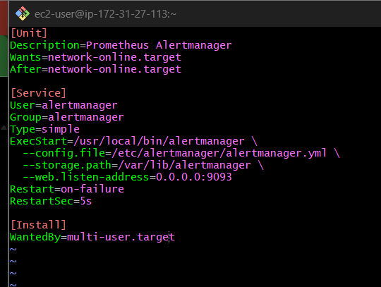
Enable and start:
sudo systemctl daemon-reload
sudo systemctl enable --now alertmanager
Verify:
sudo systemctl status alertmanager --no-pager
curl -s http://localhost:9093/-/ready
Expected service state: active (running).
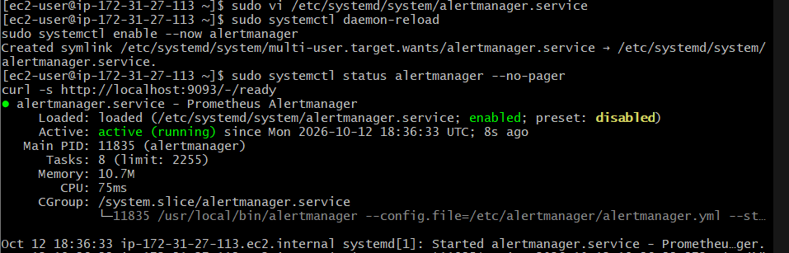
The readiness endpoint should return:
OK
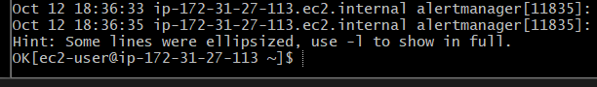

Step 5 — Connect Prometheus to Alertmanager
Edit the existing Prometheus configuration:
sudo vi /etc/prometheus/prometheus.yml
Add this top-level section, aligned with global and scrape_configs:
alerting:
alertmanagers:
- static_configs:
- targets: ['localhost:9093']
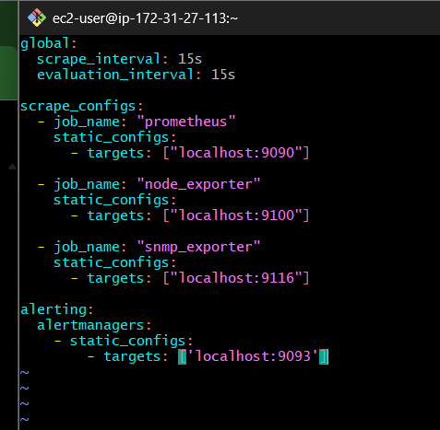
Keep your existing scrape jobs unchanged.
Validate the configuration:
sudo promtool check config /etc/prometheus/prometheus.yml
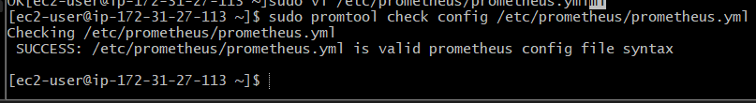
Restart Prometheus:
sudo systemctl restart prometheus
sudo systemctl is-active prometheus
Expected output:
Active
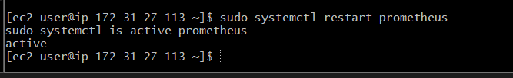

Step 6 — Create a temporary test alert
This test checks the complete Prometheus → Alertmanager → email flow. Disk-space alert rules will be configured in Task 8.
Create a rules directory and file:
sudo mkdir -p /etc/prometheus/rules
sudo vi /etc/prometheus/rules/test-alert.yml
Add:
groups:
- name: email-test
rules:
- alert: EmailTestAlert
expr: vector(1)
for: 0m
labels:
severity: warning
annotations:
summary: "Prometheus email test"
description: "Testing the Prometheus to Alertmanager email pipeline."
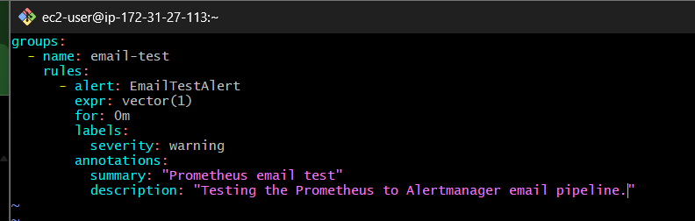
Make sure the rule file is readable by Prometheus:
sudo chown -R prometheus:prometheus /etc/prometheus/rules
Now edit /etc/prometheus/prometheus.yml again and add this top-level section:
rule_files:
- /etc/prometheus/rules/*.yml
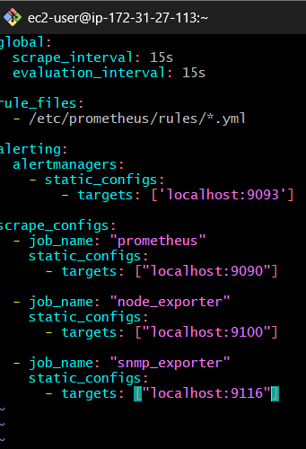
Validate and restart:
sudo promtool check config /etc/prometheus/prometheus.yml
sudo systemctl restart prometheus
Check the rule:
sudo promtool check rules /etc/prometheus/rules/test-alert.yml

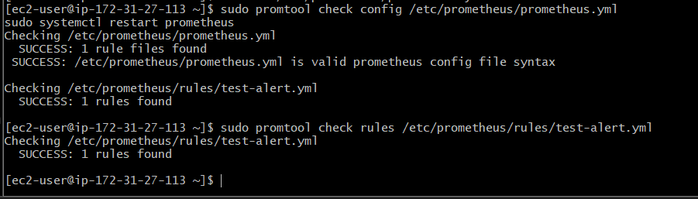

Step 7 — Verify the alert and email
- Open http://YOUR_EC2_PUBLIC_IP:9090/alerts.
- Confirm EmailTestAlert appears and becomes Firing.
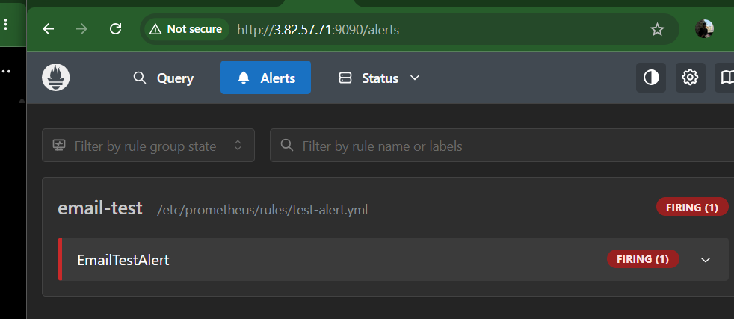
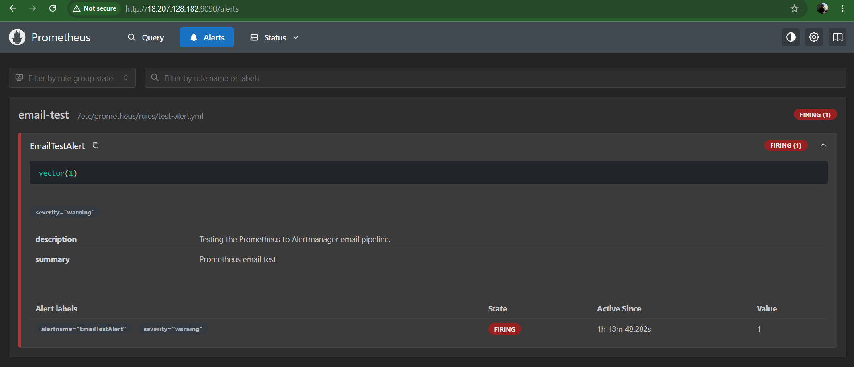
- Open http://YOUR_EC2_PUBLIC_IP:9093 and check the Alerts page.
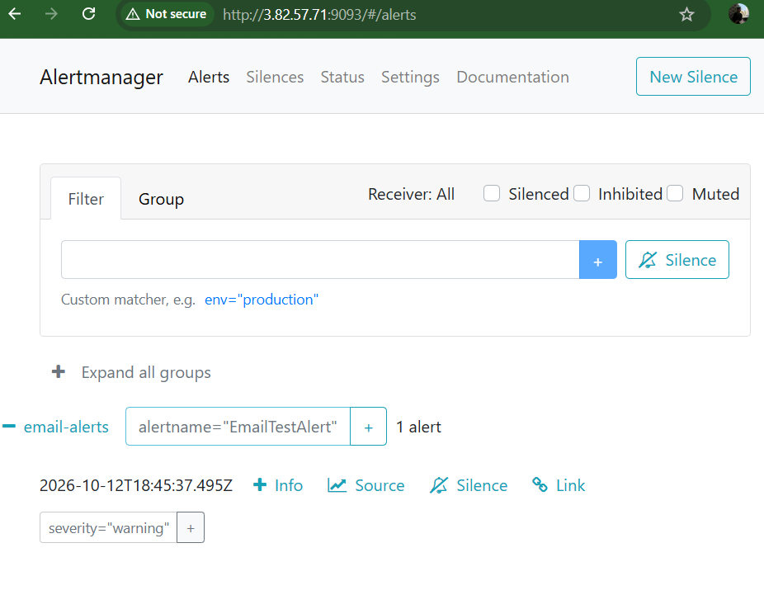
- Check the recipient inbox, including Spam or Junk.
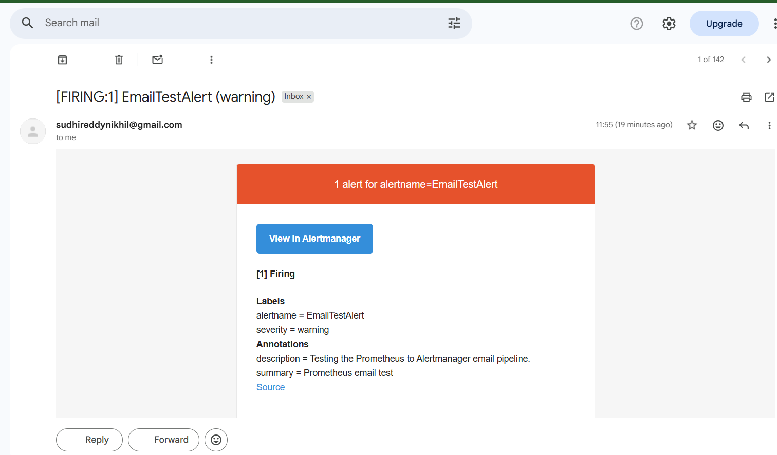
If no email arrives, inspect:
sudo journalctl -u alertmanager -n 50 --no-pager
Common causes include an incorrect App Password, SMTP authentication failure, or outbound SMTP connectivity restrictions.
After the email test succeeds, remove the temporary test-alert.yml file and its rule_files entry, then validate and restart Prometheus. We'll add the real disk-space rules in Task 8.

5.4 Outcome
- Alertmanager runs as a systemd service.
- Prometheus forwards alerts to Alertmanager.
- Email notifications are configured and tested.
- The temporary test rule is removed before moving on to the next task.

Task 6: Install and Configure Grafana
Objective: Install Grafana on your existing Amazon Linux 2023 EC2 instance and integrate it with Prometheus to visualize CPU, memory, disk, and other system metrics.
We'll continue using the same EC2 instance. No new AWS instances are needed.

Step 6.1: Add the Grafana repository
Run these commands on your EC2 instance:
sudo tee /etc/yum.repos.d/grafana.repo > /dev/null <<'EOF'
[grafana]
name=Grafana OSS
baseurl=https://rpm.grafana.com
repo_gpgcheck=1
enabled=1
gpgcheck=1
gpgkey=https://rpm.grafana.com/gpg.key
sslverify=1
sslcacert=/etc/pki/tls/certs/ca-bundle.crt
EOF
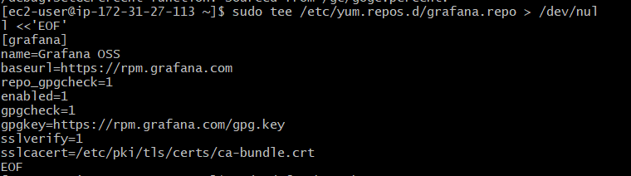
Refresh the package metadata:
sudo dnf makecache
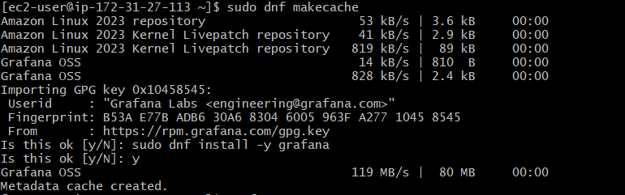

Step 6.2: Install Grafana
sudo dnf install -y Grafana
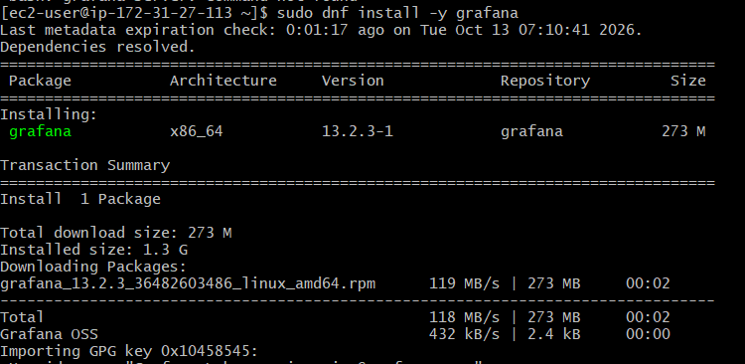
Check the installed version:
grafana-server -v
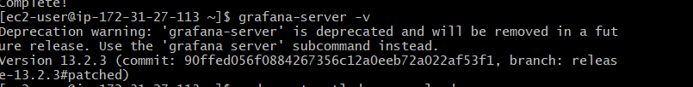

Step 6.3: Start Grafana
Enable Grafana at boot and start it now:
sudo systemctl daemon-reload
sudo systemctl enable --now grafana-server
Verify its status:
sudo systemctl status grafana-server --no-pager
Expected status:
Active: active (running)
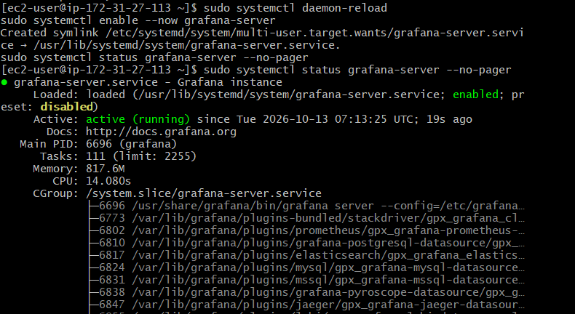
Check the local HTTP endpoint:
curl -I http://localhost:3000/login
A response such as HTTP/1.1 200 OK or a redirect indicates that Grafana's web endpoint is responding.
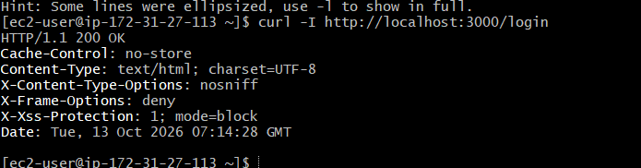

Step 6.4: Open Grafana in your browser
Grafana Web UI
Port 3000 · HTTP
Find your EC2 instance's current Public IPv4 address in the AWS Console, then open:
http://YOUR-EC2-PUBLIC-IP:3000
If the page doesn't load, check the instance's security group. Add an inbound rule for TCP port 3000 with the source restricted to your own public IP address. Do not expose Grafana to 0.0.0.0/0.
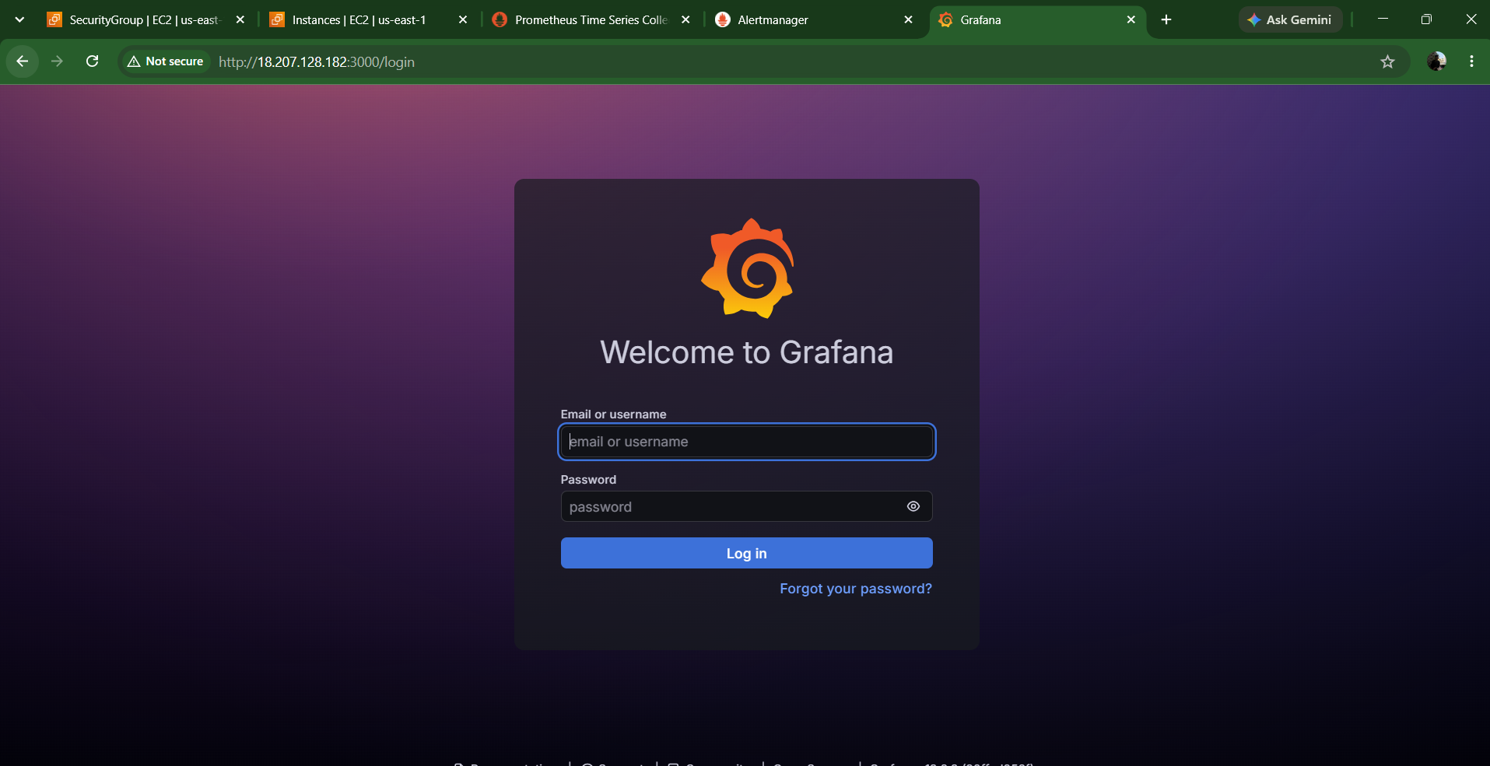
Default login for a fresh Grafana installation:
- Username: admin
- Password: admin
Grafana normally asks you to set a new password after the first login.
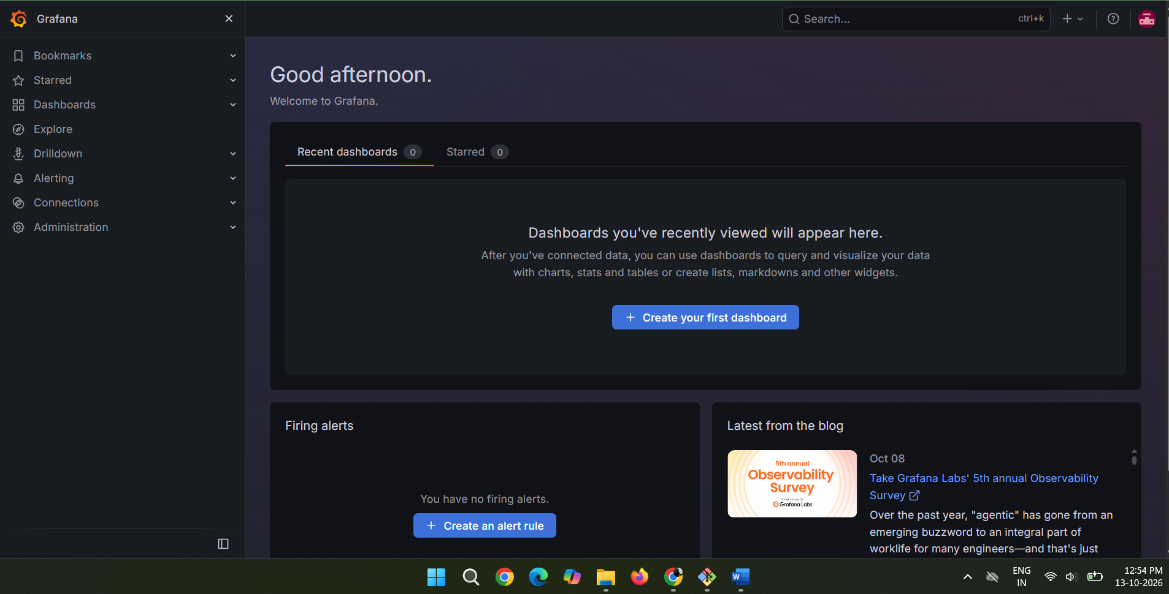

Step 6.5: Add Prometheus as a data source
In Grafana, follow these steps:
- On the left sidebar, click Connections.
- Click Data sources.
- Click Add data source.
- Select Prometheus.
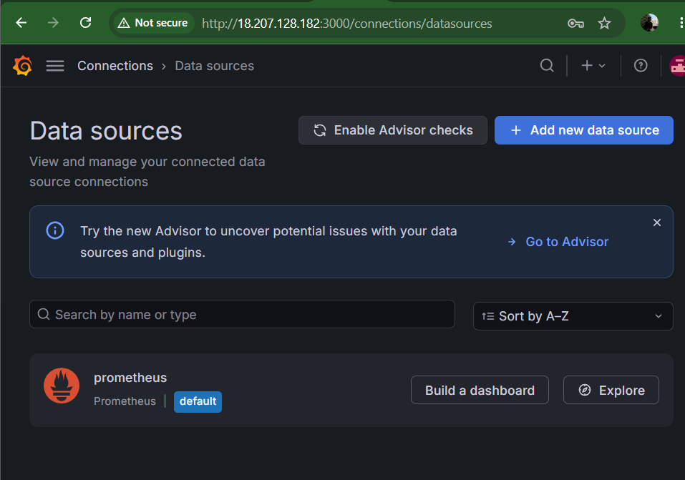

Configure the following settings:
Prometheus data source settings
Set these values in the Grafana form.
Data source name: Prometheus
Prometheus server URL : http://localhost:9090
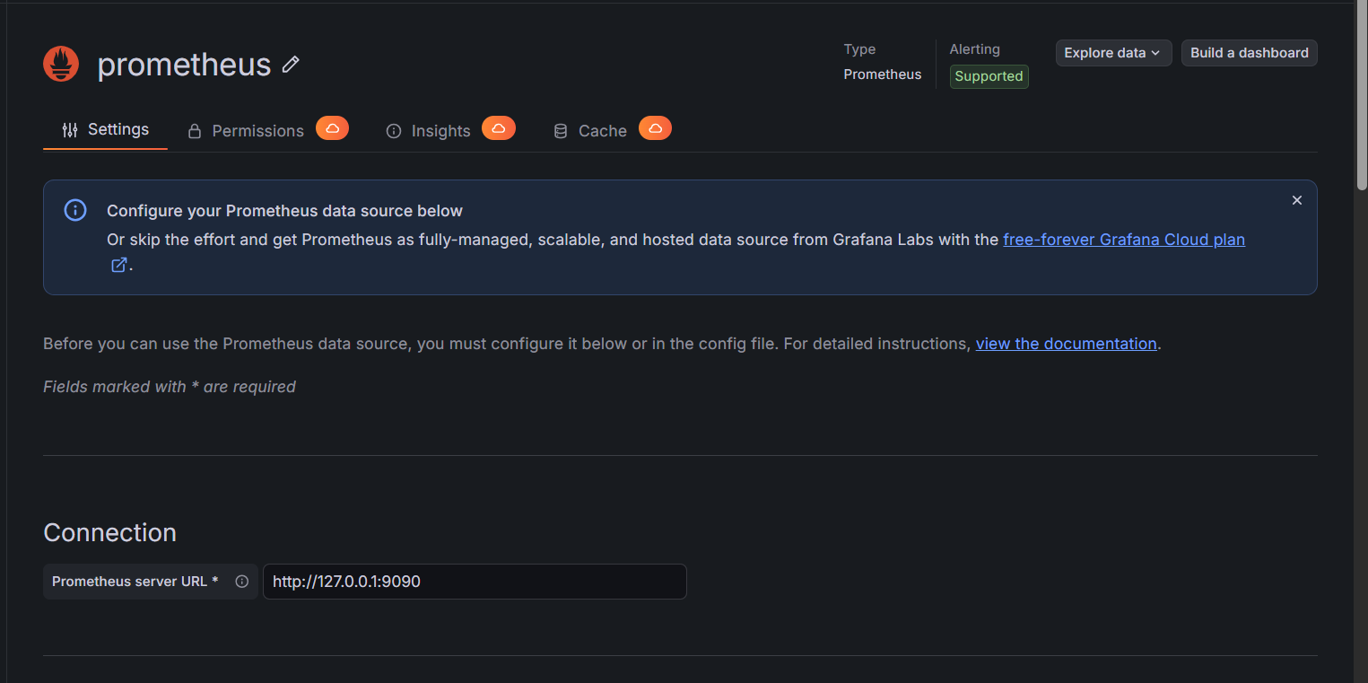
Use this URL because Grafana and Prometheus are running on the same EC2 instance.
- Leave the other settings at their defaults for now.
- Scroll down and click Save & test.
Expected result: a success message confirming that the data source is working.
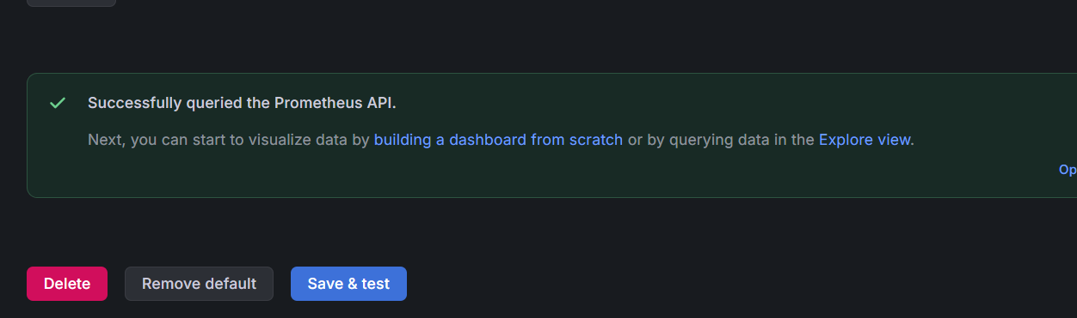

Step 6.6: Verify that Grafana can query metrics
After saving the data source:
- Open Explore from the left sidebar.
- Select the Prometheus data source.
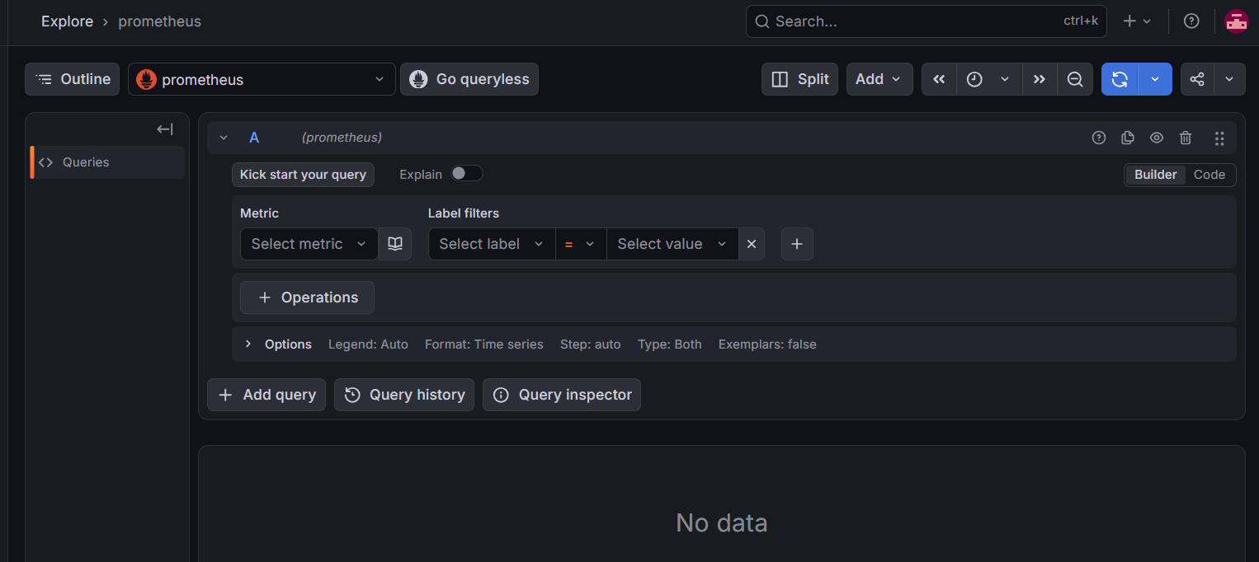
- Enter this PromQL query:
up
4. Click Run query.
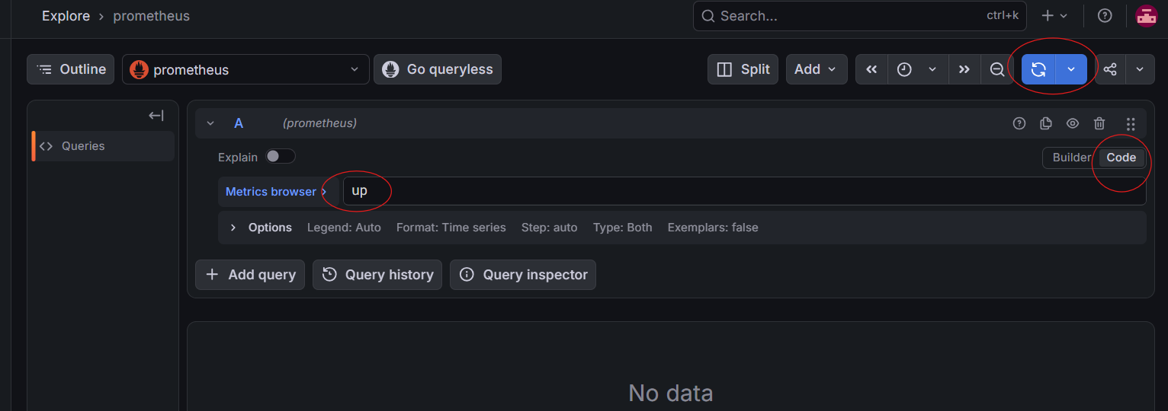
You should see three results corresponding to your Prometheus, Node Exporter, and SNMP Exporter targets, each with a value of 1.
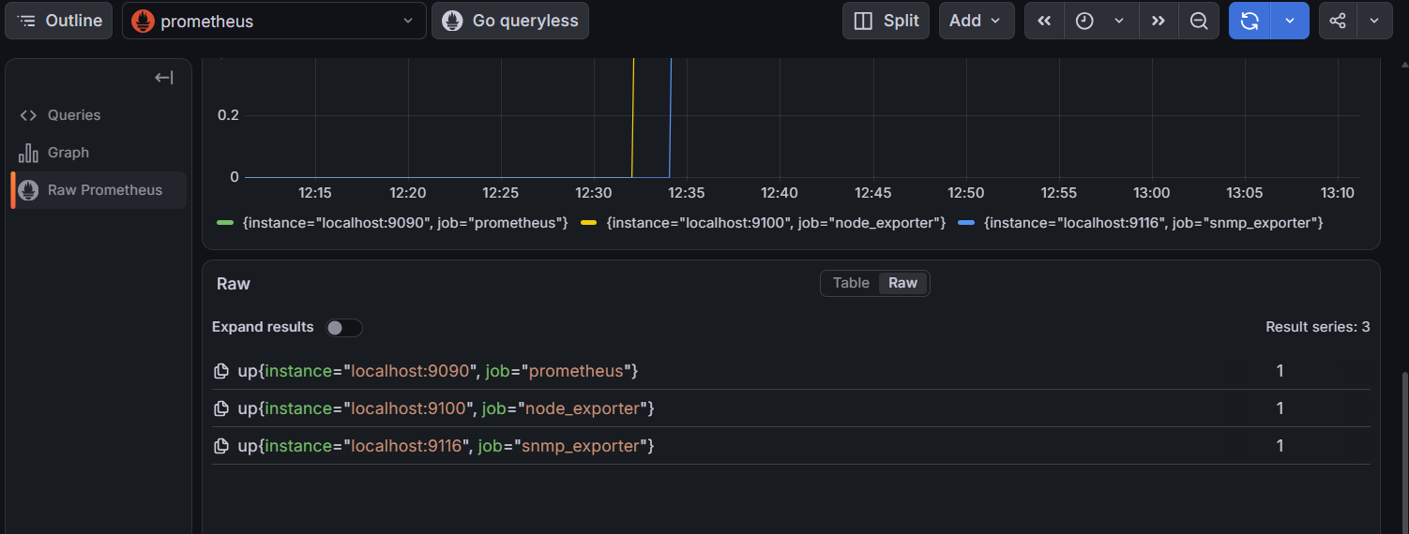

Step 6.7: Test system metrics
After up works, replace the query with each of these, one at a time.
Available memory in bytes
node_memory_MemAvailable_bytes
CPU usage percentage
100 * (1 - avg by (instance) (rate(node_cpu_seconds_total{mode="idle"}[5m])))
Disk space available in bytes
node_filesystem_avail_bytes{fstype!~"tmpfs|devtmpfs"}
Click Run queries after each query.
try:
node_memory_MemAvailable_bytes
This should return the available memory reported by Node Exporter.
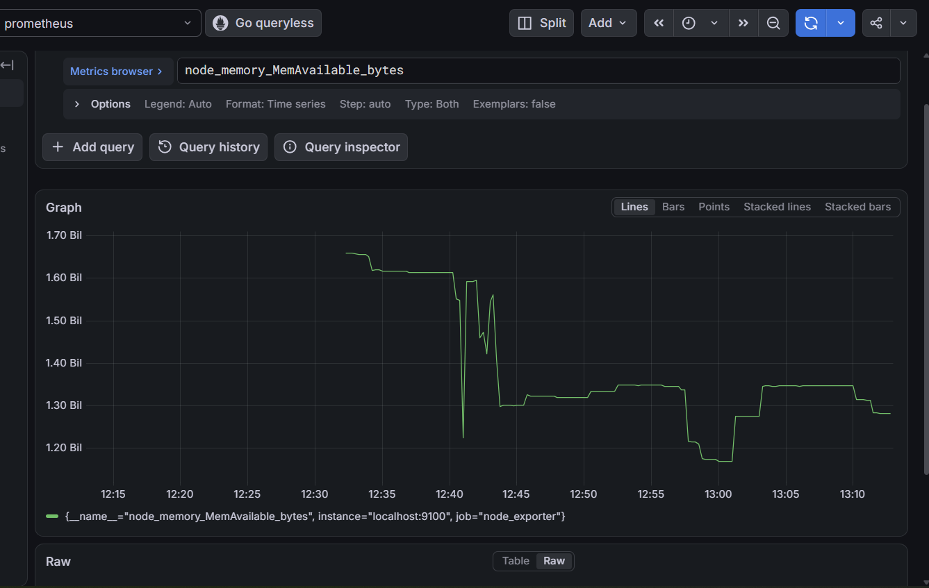
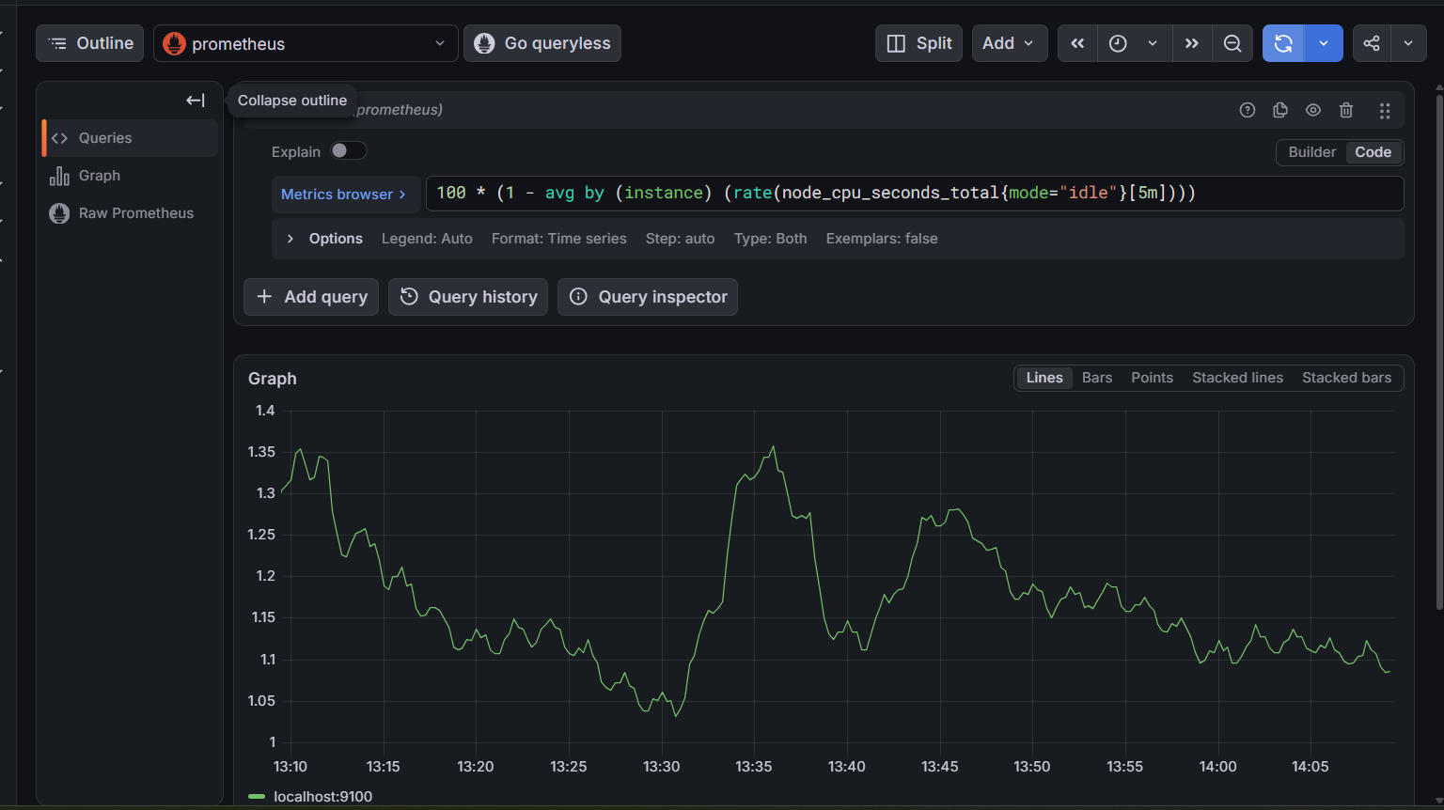
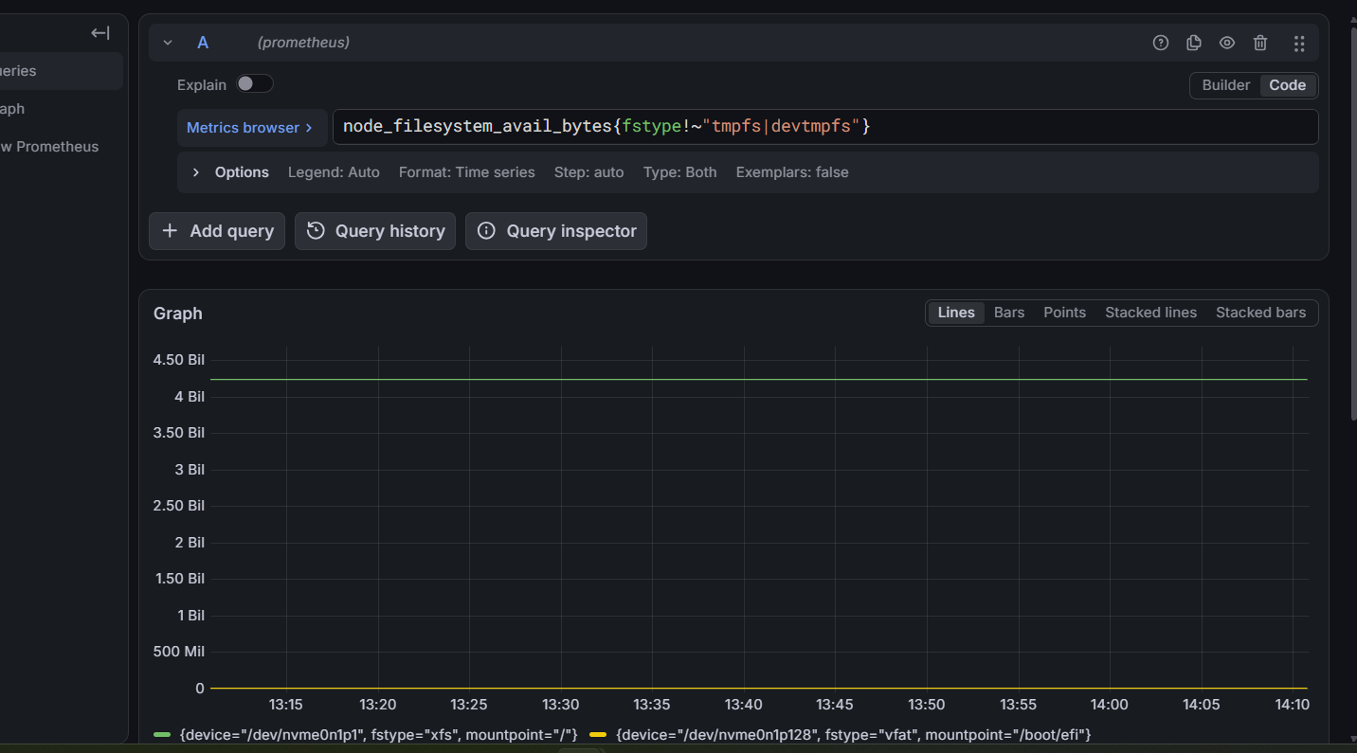

Step 6.8: Create a Grafana monitoring dashboard

1: Create a new dashboard
- In the left sidebar, click Dashboards.
- Click New → New dashboard.
- Click Add visualization.
- Select your prometheus data source.
We'll create three panels: CPU usage, memory usage, and disk space.

2: Create the CPU usage panel
Select Code in the query editor and enter:
100 * (1 - avg by (instance) (rate(node_cpu_seconds_total{mode="idle"}[5m])))
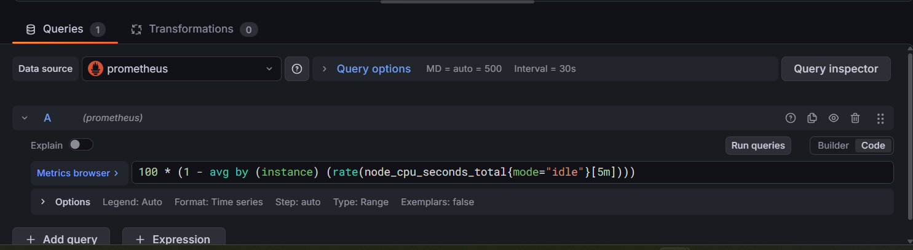
Configure the panel:
- Title: CPU Usage (%)
- Visualization: Time series
- 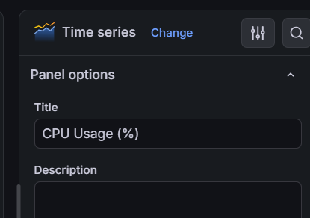
- Unit: Standard options → Unit → Percent (0-100)
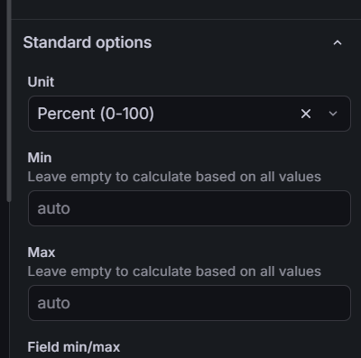

Click Run queries if necessary, then click Save dashboard and name it EC2 System Monitoring.
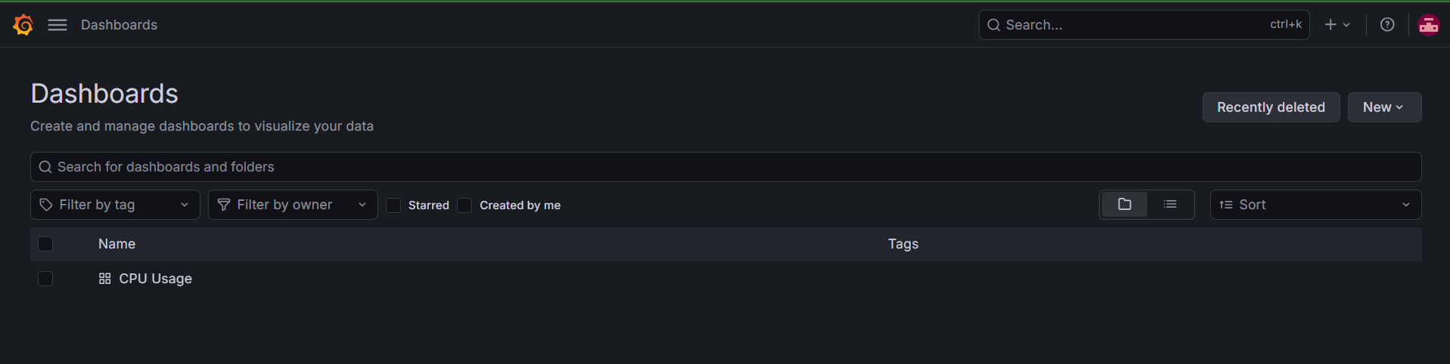

3: Add the memory usage panel
Click Add → Visualization, select Prometheus, and enter:
100 * (1 - (
node_memory_MemAvailable_bytes
/
node_memory_MemTotal_bytes
))
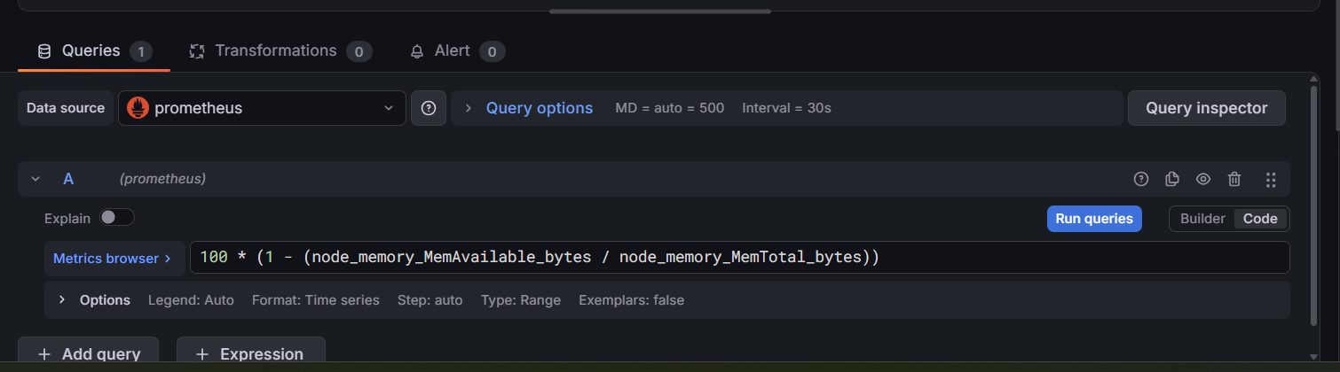
Configure:
- Title: Memory Usage (%)
- Visualization: Time series
- 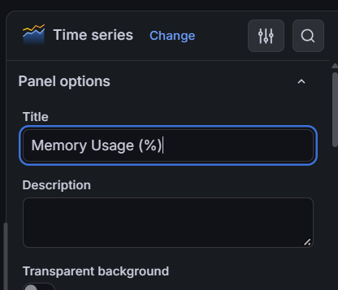
- Unit: Percent (0-100)
- 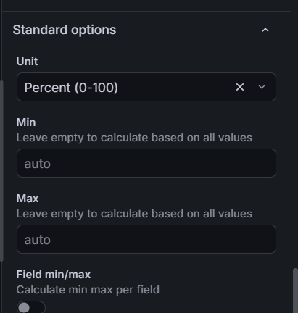
This calculates memory usage based on the memory available to the system.

4: Add the disk usage panel
Add another visualization and enter:
100 * (
1 -
(
node_filesystem_avail_bytes{mountpoint="/", fstype!~"tmpfs|devtmpfs"}
/
node_filesystem_size_bytes{mountpoint="/", fstype!~"tmpfs|devtmpfs"}
)
)
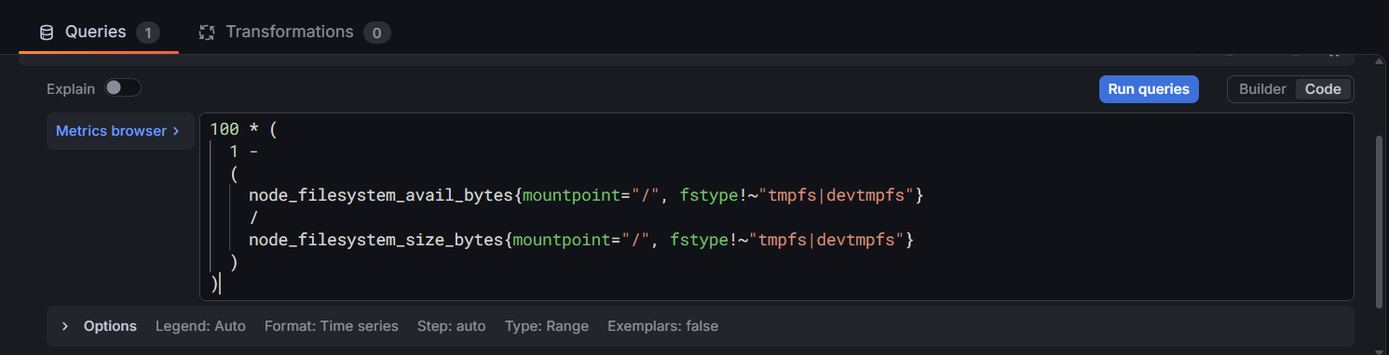
Configure:
- Title: Root Disk Usage (%)
- Visualization: Time series
- 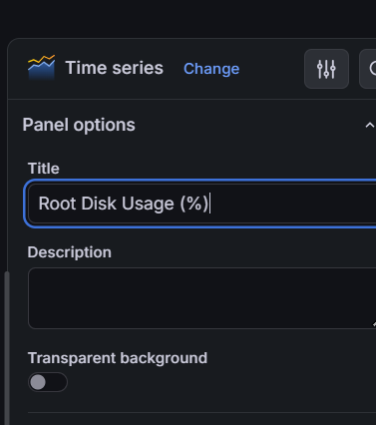

- Unit: Percent (0-100)

- 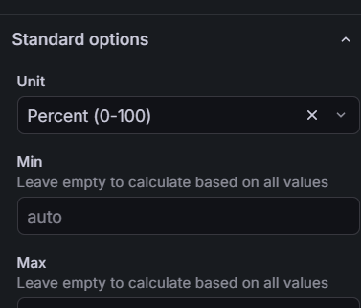
This monitors usage of the root filesystem (/). If the query returns no data, we'll inspect the filesystem labels reported by Node Exporter.

5: Save and verify
Click Save dashboard and confirm the dashboard name is cpu usage
You should now have three panels showing CPU, memory, and root disk usage. Set the dashboard time range to Last 15 minutes and use the refresh control to see updated metrics.
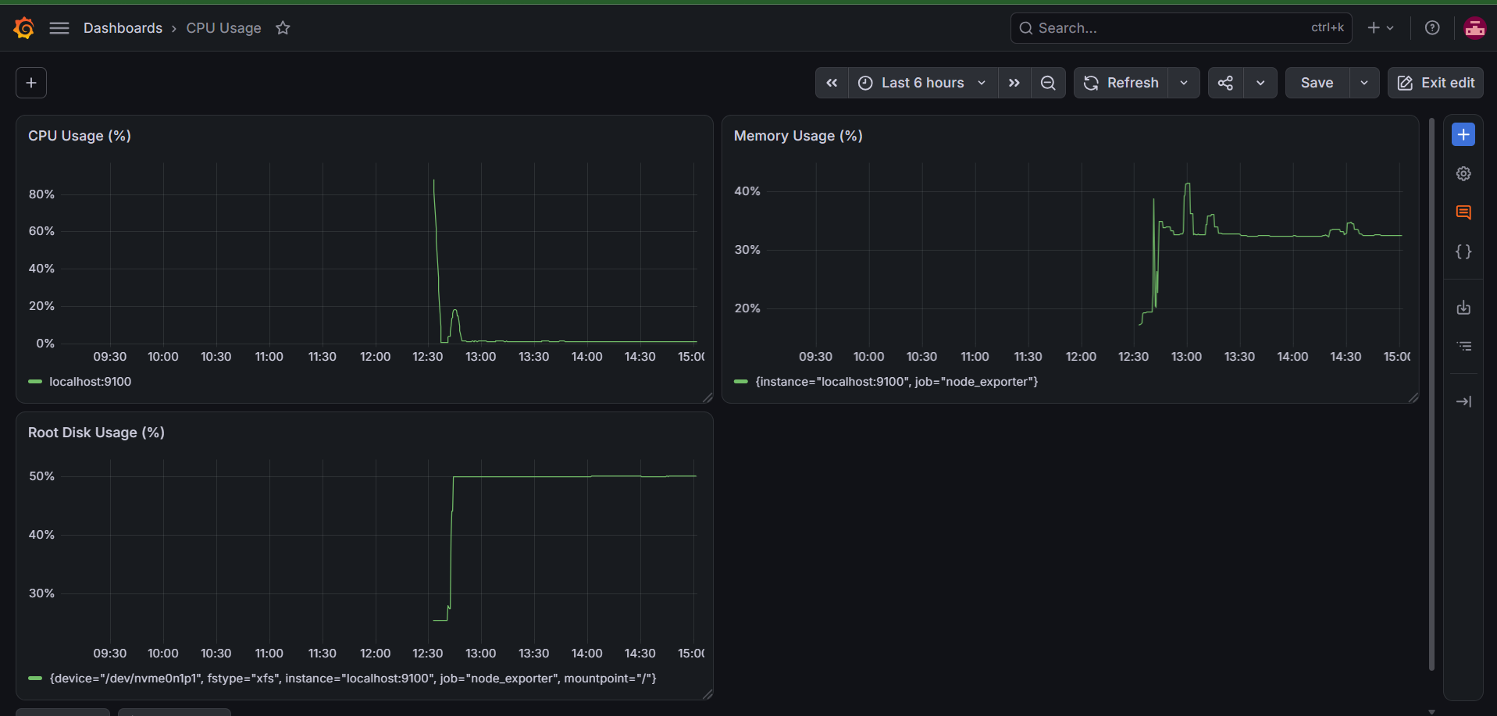

outcome
You've configured the monitoring flow:
EC2 Linux Instance
|
+--> Node Exporter (9100)
| |
| v
+----> Prometheus (9090)
|
v
Grafana (3000)
|
v
CPU / Memory / Disk
Dashboard

Task 7: Prometheus Dynamic Service Discovery
Objective: Configure Prometheus to discover monitoring targets automatically instead of manually editing prometheus.yml every time a target changes.

7.1 Understand the architecture
Target configuration file
/etc/prometheus/targets.json
Prometheus — File-based service discovery
Reads target addresses automatically
Node Exporter — port 9100
Provides EC2 CPU, memory and disk metrics
We'll use file-based service discovery first because it's simple to understand and doesn't require extra AWS permissions. Later, the same concept can be extended to AWS EC2 service discovery.

7.2 Check your current configuration
Before making changes, back up your current Prometheus configuration.
Run:
sudo cp -p /etc/prometheus/prometheus.yml \
/etc/prometheus/prometheus.yml.task7-backup
Now inspect the current file:
sudo cat /etc/prometheus/prometheus.yml
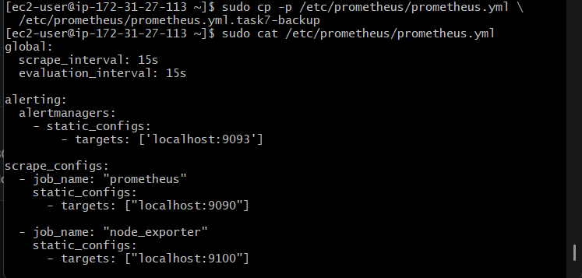

7.3: Create a target discovery file

Step 1 — Create the directory
Run:
sudo mkdir -p /etc/prometheus/file_sd

Step 2 — Create the target file
Run this complete command:
sudo tee /etc/prometheus/file_sd/node_targets.json > /dev/null <<'EOF'
[
{
"targets": ["localhost:9100"],
"labels": {
"env": "lab",
"role": "monitoring-server"
}
}
]
EOF
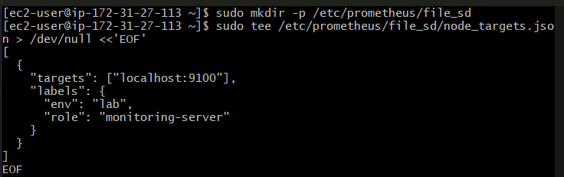
This JSON file defines the Node Exporter target and adds two labels so you can identify it in Prometheus queries.

Step 3 — Validate the JSON
Run:
python3 -m json.tool /etc/prometheus/file_sd/node_targets.json
Expected: the JSON prints in formatted form without errors.
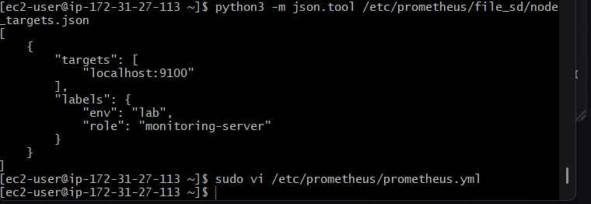

7.4: Update Prometheus configuration
We'll replace only the existing node_exporter job with a file-based discovery job. Keep the other two jobs unchanged.
Open the configuration:
sudo vi /etc/prometheus/prometheus.yml
Find this section:
- job_name: "node_exporter"
static_configs:
- targets: ["localhost:9100"]
Replace it with:
- job_name: "node_exporter"
file_sd_configs:
- files:
- "/etc/prometheus/file_sd/node_targets.json"
refresh_interval: 30s
In vi, press i to edit. When finished, press Esc, type :wq, and press Enter.
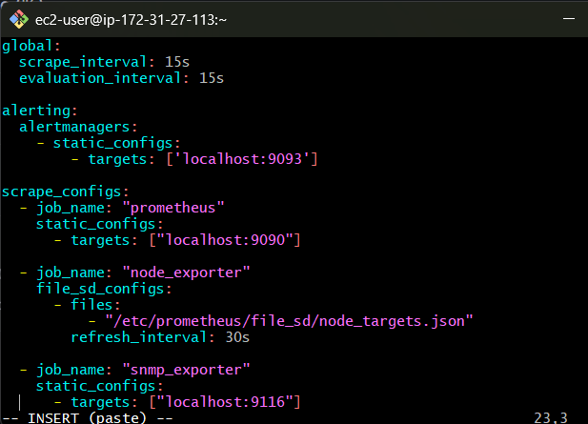
Don't change the Prometheus or SNMP Exporter jobs.

Step 5 — Validate the configuration
Run:
sudo promtool check config /etc/prometheus/prometheus.yml
Expected:
SUCCESS: /etc/prometheus/prometheus.yml is valid prometheus config file syntax
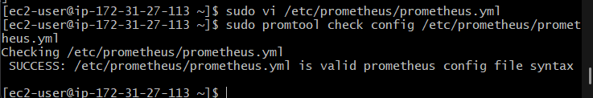

7.5: Restart Prometheus
Run:
sudo systemctl restart prometheus
Check the service:
sudo systemctl status prometheus --no-pager
Expected: Active: active (running).
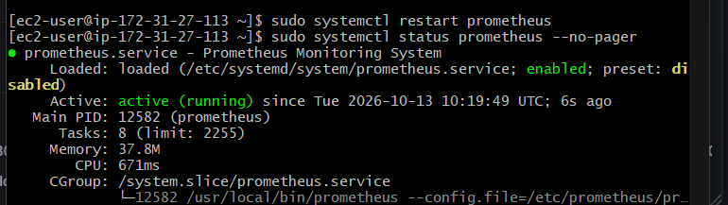

7.6: Verify service discovery
Wait about 30 seconds for the file-based discovery refresh, then run:
curl -s http://localhost:9090/api/v1/targets | python3 -c '
import json, sys
data = json.load(sys.stdin)
for t in data["data"]["activeTargets"]:
print("Job:", t["labels"].get("job"))
print("Instance:", t["labels"].get("instance"))
print("Health:", t["health"])
print("Labels:", t["labels"])
print("-" * 30)
'
You should see all three jobs healthy (up). For node_exporter, the target should include the labels env="lab" and role="monitoring-server".
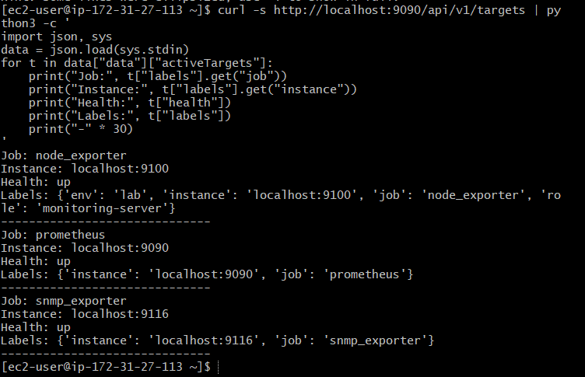

Task 8: Configure Prometheus Alert Rules
Objective: Configure Prometheus to detect high CPU usage, high memory usage, and high disk usage, then send alerts through your existing Alertmanager and Gmail integration.

8.1 — Understand the alerting flow
Node Exporter
Collects CPU, memory and disk metrics
Prometheus alert rules
Evaluates thresholds every 15 seconds
Alertmanager — port 9093
Receives and routes firing alerts
Gmail notification

8.2 — Create the alert rules directory
Run on your EC2 instance:
sudo mkdir -p /etc/prometheus/rules

8.3 — Create CPU, memory and disk alert rules
Run this entire command:
sudo tee /etc/prometheus/rules/system-alerts.yml > /dev/null <<'EOF'
groups:
- name: system-resource-alerts
rules:
- alert: HighCPUUsage
expr: 100 * (1 - avg by (instance) (rate(node_cpu_seconds_total{mode="idle"}[5m]))) > 80
for: 2m
labels:
severity: warning
annotations:
summary: "High CPU usage detected"
description: "CPU usage on {{ $labels.instance }} has exceeded 80% for 2 minutes."

- alert: HighMemoryUsage
expr: 100 * (1 - (node_memory_MemAvailable_bytes / node_memory_MemTotal_bytes)) > 80
for: 2m
labels:
severity: warning
annotations:
summary: "High memory usage detected"
description: "Memory usage on {{ $labels.instance }} has exceeded 80% for 2 minutes."

- alert: HighDiskUsage
expr: 100 * (1 - (node_filesystem_avail_bytes{mountpoint="/",fstype!~"tmpfs|devtmpfs"} / node_filesystem_size_bytes{mountpoint="/",fstype!~"tmpfs|devtmpfs"})) > 80
for: 2m
labels:
severity: warning
annotations:
summary: "High root disk usage detected"
description: "Root filesystem usage on {{ $labels.instance }} has exceeded 80% for 2 minutes."
EOF
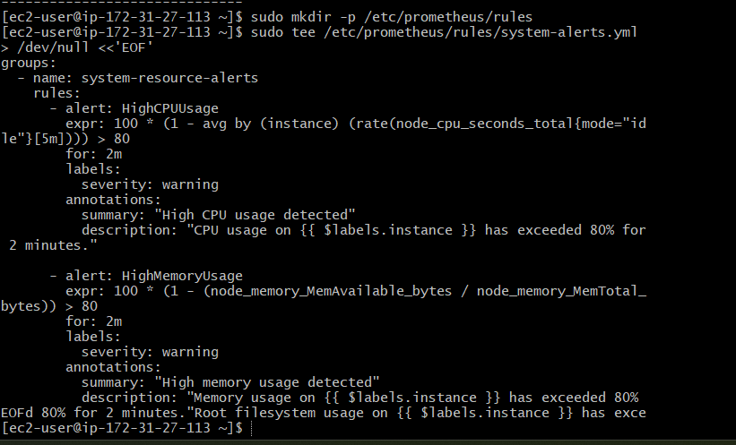
These rules trigger only if the relevant resource usage stays above 80% for two minutes. This reduces alerts caused by brief spikes.

8.4 — Validate the alert rules
Run:
sudo promtool check rules /etc/prometheus/rules/system-alerts.yml
Expected result: SUCCESS for all three rules.
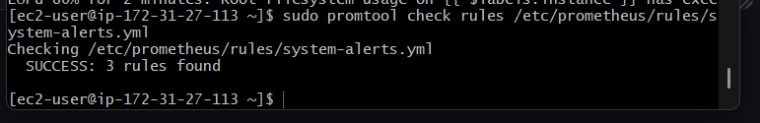

8.5 — Connect the rules to Prometheus

Step 1: Update Prometheus configuration
Open the configuration:
sudo vi /etc/prometheus/prometheus.yml
Add the following at the top level, aligned with global:, alerting:, and scrape_configs::
rule_files:
- "/etc/prometheus/rules/system-alerts.yml"
Your configuration should now contain all four sections: global, alerting, rule_files, and scrape_configs. Keep the existing settings and jobs unchanged.
Save and exit vi using Esc, then :wq, then Enter.
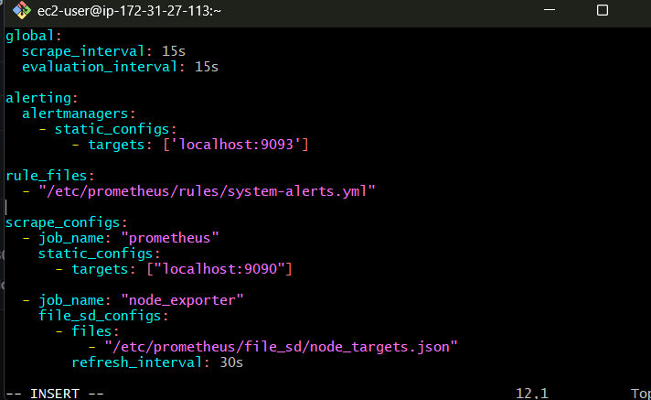

Step 2: Validate the full configuration
sudo promtool check config /etc/prometheus/prometheus.yml
Expected: configuration is valid, and the three alert rules are loaded from the rules file.
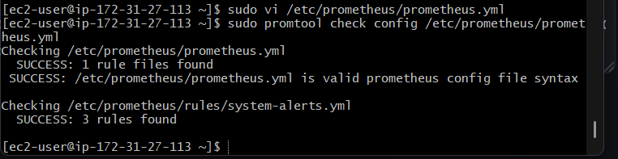

Step 3: Restart Prometheus
sudo systemctl restart prometheus
sudo systemctl status prometheus --no-pager
Confirm the service is active (running).
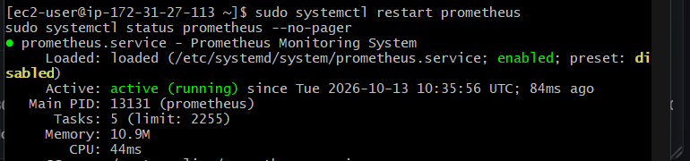

Step 4: Verify that the rules are loaded
curl -s http://localhost:9090/api/v1/rules
You should find these alert names in the response:
- HighCPUUsage
- HighMemoryUsage
- HighDiskUsage
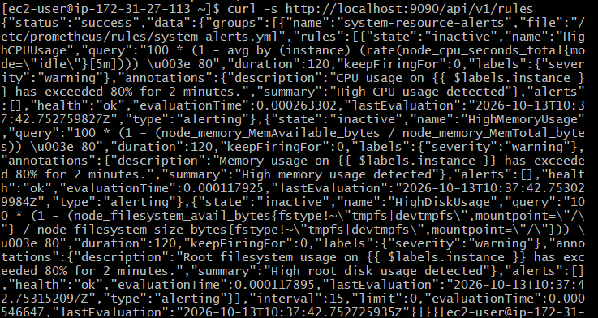
You can also open Prometheus's Alerts page at http://YOUR-EC2-PUBLIC-IP:9090/alerts if your security group allows access from your own IP.
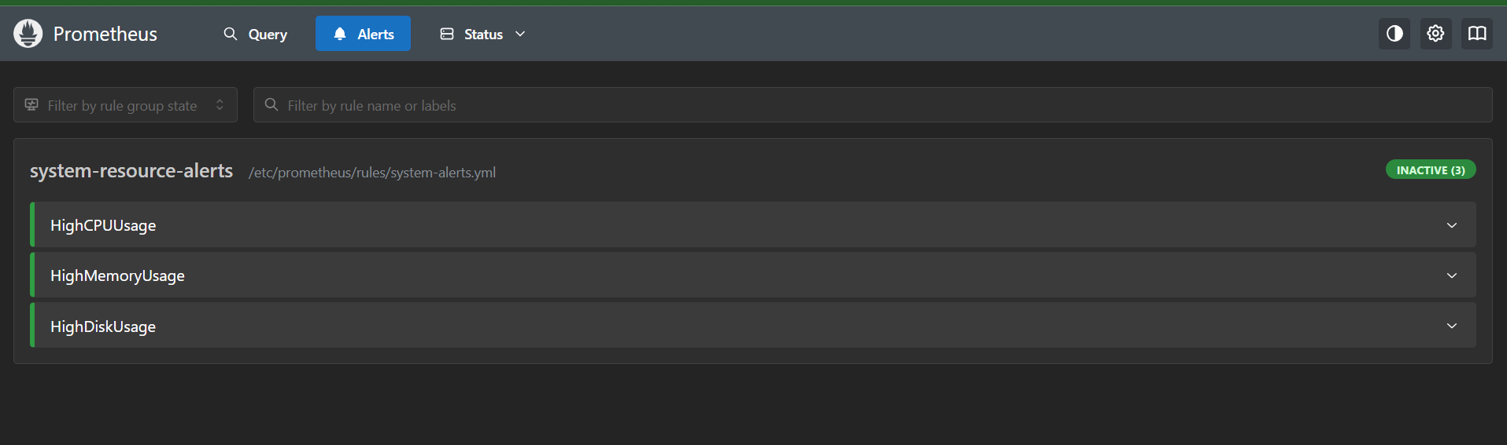

8.6 — Verify the loaded alerts
Run this command:
curl -s http://localhost:9090/api/v1/rules | python3 -c '
import json, sys
data = json.load(sys.stdin)
for group in data["data"]["groups"]:
print("Group:", group["name"])
print("Health:", group["health"])
for rule in group["rules"]:
print("Alert:", rule.get("name"))
print("State:", rule.get("state"))
print("-" * 30)
'
Expected alert names:
- HighCPUUsage
- HighMemoryUsage
- HighDiskUsage
Their states will likely be inactive because your instance is not currently exceeding the 80% thresholds. That's normal and means the rules are loaded but not firing.
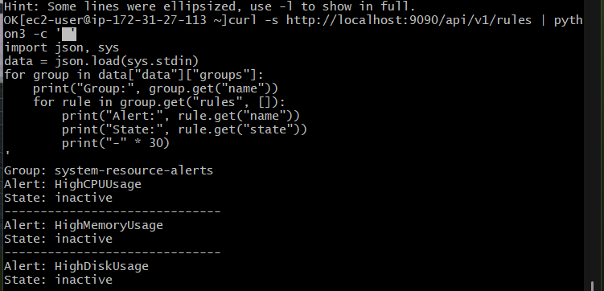

8.7 — Verify Alertmanager
Next, run:
sudo systemctl status alertmanager --no-pager
curl -s http://localhost:9093/-/ready
Expected: Alertmanager is active, and its readiness endpoint responds that it is ready.
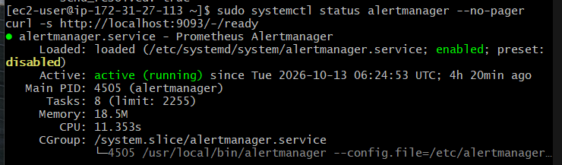

8.8 — Test the email alert safely
Since you previously confirmed that a test email arrived from Alertmanager, we can test the full alert path without generating artificial CPU or memory load.
First, check the current Alertmanager configuration:
sudo cat /etc/prometheus/prometheus.yml
sudo cat /etc/alertmanager/alertmanager.yml
We need to confirm that Prometheus is configured to send alerts to localhost:9093 and that Alertmanager's existing email receiver remains configured.
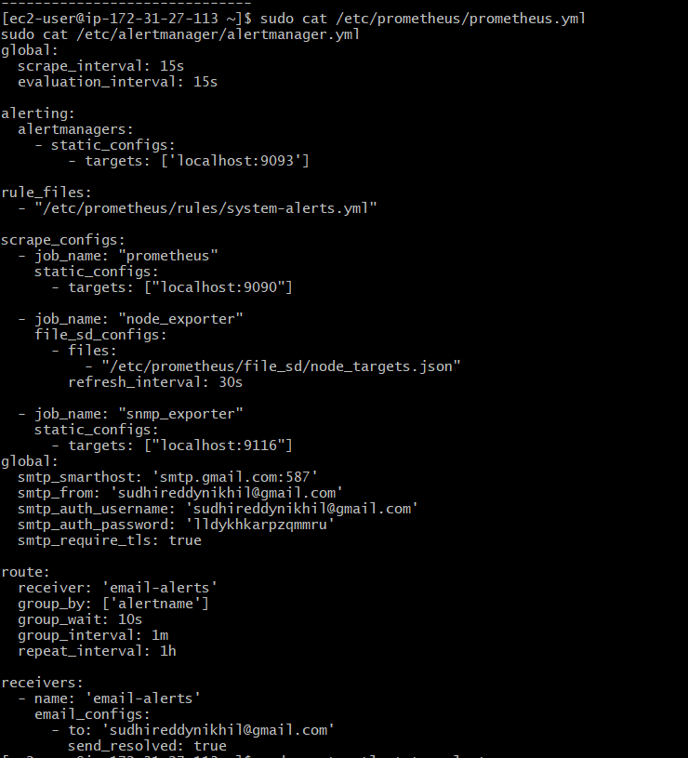

Task 9: Create a Custom Grafana Dashboard
Objective: Build a Grafana dashboard to monitor your EC2 system using Prometheus metrics.
Planned panels:
- CPU Usage (%)
- Memory Usage (%)
- Root Disk Usage (%)
- Network Traffic
Your CPU and Memory panels are already created, so we won't recreate them.

Step 9.1: Add Network Traffic Monitoring
Let's add one new panel to your existing dashboard to monitor incoming and outgoing network traffic.
In Grafana:
- Open your existing dashboard.
- Click Add → Visualization.
- Select your existing Prometheus data source.
- In the query editor, select Code mode and enter this query for incoming traffic:
rate(node_network_receive_bytes_total{device!="lo"}[5m]) * 8
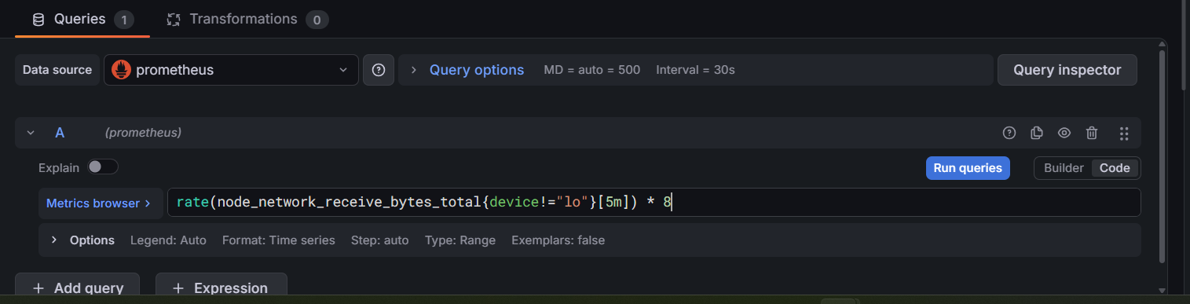
- Set the visualization to Time series.
- Set the title to Network Incoming Traffic.
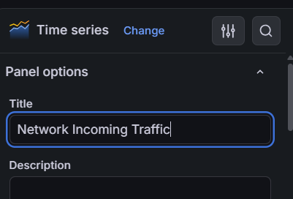
- Set the unit to bits/sec (SI).
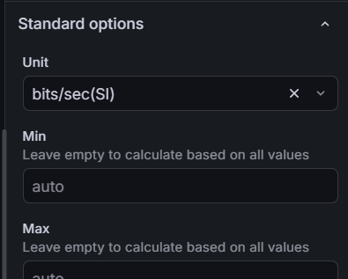
- Click Apply.
This panel shows incoming network traffic over time, excluding the loopback interface.
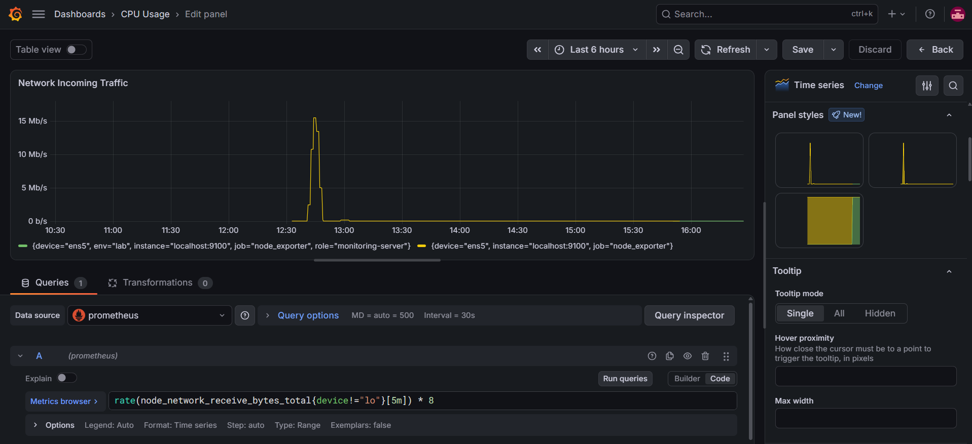

Step 9.2: Add Network Outgoing Traffic
Now we'll monitor traffic sent out by your EC2 instance.
- Open your existing dashboard.
- Click Add → Visualization.
- Select the Prometheus data source.
- In Code mode, enter this query:
rate(node_network_transmit_bytes_total{device!="lo"}[5m]) * 8
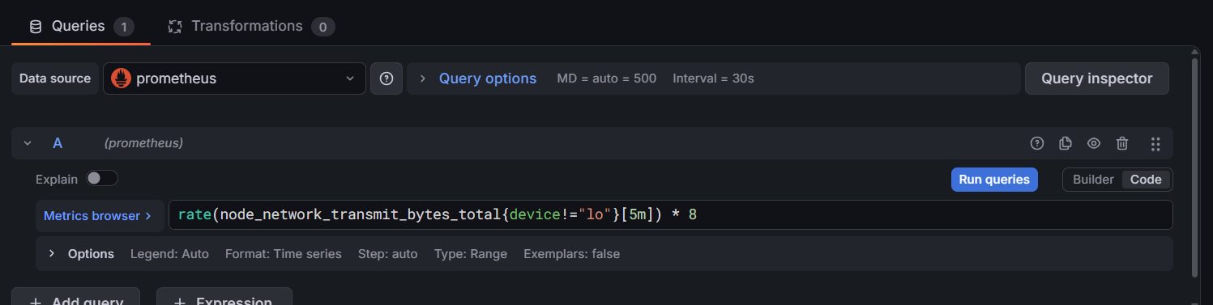
- Set visualization to Time series.
- Set the panel title to Network Outgoing Traffic.
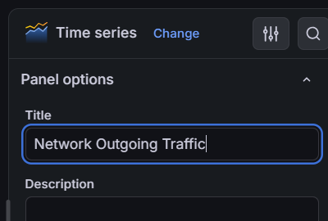
- Set the unit to bits/sec (SI).
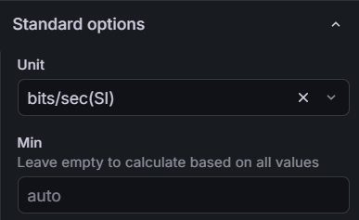
- Click Apply, then save the dashboard.
This measures outgoing network traffic in bits per second.

Step 9.3 — Verify the dashboard
Open your dashboard and confirm that all five panels are visible.
